**Real-time Simulation of wind flow through an urban environment in Unity.**

Joshua Milner (210181083)

May 2024

BSc. Computer Science

Supervisor - Giacomo Bergami

Word Count: 14,365

# Abstract

The study of wind flow through an urban area is integral to help architects and engineers better understand the wind patterns their buildings produce. Computational fluid dynamics (CFD) software is often used to simulate wind flow, but it demands a previous technical understanding and requires extensive computational resources or time. This project aims to address these challenges by developing an accessible, real-time wind flow simulator in the Unity game engine. By adapting a previous CFD solver, this wind simulator allows users to place building and easily interpret wind flow through visualisations. Validation is done on the simulations results against wind-tunnel data to ensures accurate wind flow is being produced. Testing and optimisation of the algorithms ensures they remain efficient and accessible. This dissertation enables architects to simulate wind flow through an urban area quickly, and without the complexities of current CFD software.

# Declaration

“I hereby declare that this dissertation represents my own work, except where  
otherwise stated.”

# Acknowledgements

I would like to express my profound appreciation to my supervisor, Giacomo Bergami. His intellectual rigor, insightful questions, and commitment to the development of this project pushed me to achieve my full potential in this dissertation.

I would also like to thank Daisy-Grace Dobbing for her support and motivation throughout this dissertation.

Table of Contents

Abstract 2

Declaration 3

Acknowledgements 4

Introduction 7

Context for the project 7

Definition of the problem 7

Proposed solution 8

Aims and Objectives 8

Dissertation structure 9

Technical Background 10

Current techniques for visualising wind flow 10

SimScale 10

M. B. a. V. Cristie, “CFD Post-processing in Unity3D” 11

S. Schneider, “EXPLORING SCHEMES FOR VISUALIZING URBAN WIND FIELDS BASED ON CFD SIMULATIONS BY EMPLOYING OGC STANDARDS” 11

Current papers simulating wind flow in an urban area 11

K. Tsai, “Evaluating the Influence of Urban Morphology on Urban Wind Environment Based on Computational Fluid Dynamics Simulation” 12

Z. Kaseb, “A framework for pedestrian-level wind conditions improvement in urban areas: CFD simulation and optimization” 12

Y. Xiao, et al., "Effects of inflow conditions on mountainous/urban wind environment simulation" 13

M. Tutar And G. Oguz, "Computational modelling of wind flow around a group of buildings” 13

Jon Stam “Real-Time Fluid Dynamics for Games” 14

Choice of fluid solver 14

Why Computational fluid dynamics is necessary 16

Implementation 17

Ethical considerations 17

Fluid simulation 17

Fluid solver - Main loop 19

Advect 20

Diffuse 21

Project 23

Add forces 24

Boundary conditions 26

Visualisation techniques 29

Wind speed and direction texture 29

Wind speed texture 30

Wind Direction with gizmos 32

Results and Evaluation 35

Grid density testing and evaluation 35

Validating the wind simulation 37

Building density testing and evaluation 39

Building density effect on simulation runtime 40

Building density effect on memory usage 42

Building density effect on simulation accuracy 43

Correctness testing the 2D and 3D wind simulations 44

Conclusion 47

Future work 47

Summary 48

Bibliography 49

# Introduction

## Context for the project

Urban landscapes can create complex wind patterns, leading to wind discomfort and danger in some regions, while leaving other regions to suffer from poor outdoor ventilation [1]. It is of the uttermost importance for architects and engineers to understand better the wind flow patterns their building could create. This then substantiated relevant boosts on this research area. Overall, the technologies used to simulate wind flow in urban environments use computational fluid dynamics (CFD) to do so. While there is CFD software such as OpenFOAM [2] and SimScale [3] , which can be used to simulate wind flow in urban environments, this requires a technical understanding on how to set up the building’s parameters such as complex boundary conditions (which define how fluids should act at boundaries) so that the simulation is accurate. Furthermore, such software also requires large amounts of computational power or time due to the underlying equations that need to be solved. On the other hand, Current games characterization of such events are quite simplistic; the well-known paper by Jon Stam “Real-Time Fluid Dynamics for Games” [4], despite discussing the way to simulate fluids using CFD, does not describe this neither in the context of wind in an urban scenario, nor provides effective ways to validate the algorithm. However, it is able to produce fluid simulations in real time without much computational power.

Another useful tool for architects and engineers to understand wind patterns cities can create is modelling software. The aforementioned CFD software does not allow the creation of models inside the software. This means that other programs are needed to create the complex models to represent the urban area, such as CAD software, but this is also a complex tool which can be difficult to use without the proper experience.

## Definition of the problem

There may be many studies of wind flow in urban areas using CFD, but most of these studies are on specific regions or city landscapes. If someone wanted to use a CFD implementation for a new building proposal, a whole new model of the city would have to be made and possibly new boundary conditions. Furthermore, the specific CFD implementation would have to be fully understood to accurately recreate it. Lastly, some CFD implementations can take up to12 days to fully solve on a personal computer [1]. This may be too complicated and time consuming for some people who wish to observe wind flow in an urban area. Therefore, a software that is easy to use, prioritises performance, and enables buildings to be added and moved easily inside the simulation, would significantly increase the accessibility of simulating wind flow in an urban area.

There are many different solutions to simulating wind flow in urban areas using CFD, but the accuracy of the simulations results needs to be accessed accurately and precisely. One method of validating CFD is with real word monitored data as seen in the paper by Ku, Chia-An, and Hung-Kai Tsai [5]. However, this method of validation is almost impossible in simulations where the city or environment does not exist, as there is no monitored data to compare it with. The problem is validating the accuracy of the wind simulations through an urban environment. This is important because if the data is being used when considering building designs and placements, and the simulations are not correct, it could have drastic real-life consequences. Therefore, ensuring the validity of the CFD wind simulations could be done by comparing them with the wind-tunnel measurements of mean wind speed for a generic urban area by Nonomura et al [6].

## Proposed solution

Reflecting on the difficulties and current limitations of simulating accurate wind flow in CFD research, I intend to produce an accessible and accurate simulation of wind flow through an urban environment in using CFD. The hope is to produce wind which realistically responds to buildings, providing a useful piece of software for architects and engineers. It will attempt to reduce the barriers of computation and the need for previous knowledge by aiming to produce a real time simulation that is easy to use. Also, to reduce the need for separate modelling software, it will allow urban areas to be created in the simulation with the ability to place buildings.

I will adapt a CFD simulation for use in the Unity game engine. I plan to program my wind simulation to run on the CPU. Both accuracy and performance of the simulation will be a priority.

## Aims and Objectives

The main aim of this project is to produce a realistic simulation of wind flow through an urban environment, in the unity game engine, resulting in an easy-to-use and accessible piece of software. Furthermore, I aim to compare different algorithms for simulating wind, by comparing their efficiency and accuracy. I intend to implement a way of visualizing the wind flow to help evaluate the accuracy of the simulation.

To help achieve my aim, the project was abstracted into a number of objectives. If all the objectives are fully met by the end of the project, it will be deemed successful.

Objectives:

1. An interactive wind simulator has been produced in the Unity game engine, in which the user can place and move buildings, and designate wind direction and strength through a basic UI. The simulation can then be executed, and it should determine the wind flow around the buildings. **Outcome:** This objective was successfully achieved, as demonstrated by the simulator's functionality and correctness testing (p.44).
2. Validate the accuracy of the CFD algorithms by comparing them with the wind-tunnel measurements of mean wind speed for a generic urban area by Nonomura et al [6]. This can be done by providing a clear representation of the wind flow using textures and shaders. This should focus on simplicity as it is will mostly be used as a visual way of validating the correctness of the wind flow. It should also be easily understood by anyone without prior knowledge. A good visualisation will clearly show the direction and magnitude of the wind. **Outcome:** Validation proved the simulation does produce an accurate wind simulation; specific results can be found in the validation section (p.37).
3. Accurate testing and optimisation of the wind simulation algorithm has been done. By comparing two or more different CFD implementations to provide the most accurate wind simulation. **Outcome:** A comparison was done between the 2D, and 3D simulations run time against grid density finding a negative correlation (p.35).
4. Successfully investigate the change in simulating wind flow accuracy through the urban environment against performance, by altering parameters such as the number of buildings, the overall grid density, wind direction, and wind speed. **Outcome:** Testing uncovered performance constraints, particularly regarding high building densities; optimisations mitigated performance decline with increasing building density (p.40).

## Dissertation structure

This dissertation is made up of 5 sections:

1. Introduction – In this section, the motivations for the project are outlined, along with a definition of the problem I intend to solve. An overview of my proposed solution and my aims and objectives to help me achieve it are also explained.
2. Background Research – This section discusses the relevant literature which was used to motivate my project and design choices. The reasons why certain visualisation techniques where chosen. It also justifies the use of specific algorithms that were used for the fluid solver.
3. Implementation – A detailed description of the workings of the specific functions that make up the wind simulation are explained in this section. Along with why specific implementation decisions were made. The main fluid solver algorithm is discussed first, then a description of how the visualisations were implemented.
4. Results and Evaluation – The contents of this section discuss the results of various tests done on the simulation. Optimisations that were made are justified and the extent of their effect is investigated. Validation is also done to ensure the wind simulation produces accurate wind flow. Lastly, correctness tests are done on the wind simulation to also ensure proper functionality.
5. Conclusion – This section summarises the successfulness of the project as a whole, and as to whether the objectives of the project were met. Possible future work is also discussed.

# Technical Background

## Current techniques for visualising wind flow

To decide which methods would be used in visualising the wind flow, I needed to consider the techniques relevant literature and software were using to also visualise wind flow through an urban area.

### SimScale

The main consideration when researching was a software called SimScale [3], which is a CFD software that specialises in simulating wind comfort in urban areas. The reason this was particularly useful in understanding the ways in which wind flow is represented is because the software has been specially designed to clearly show wind flow with different visualisation techniques. One of the techniques this software uses is showing wind speed on a texture, underneath the building models. SimScale’s visualisation of wind speed can be seen in Figure 1.

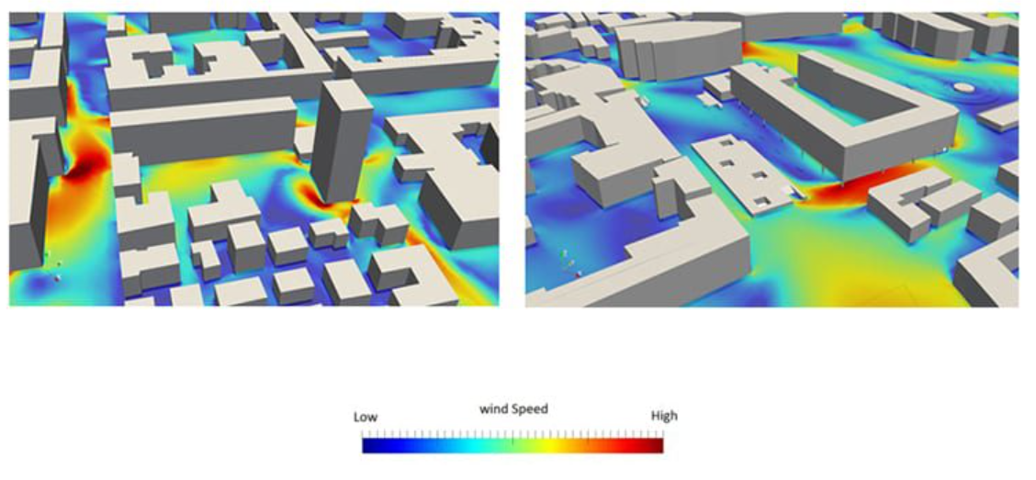

Figure 1

This method seemed particularly intuitive and easy to understand, which is important in helping my wind simulation be as accessible as possible. Therefore, an implementation for visualising wind speed like the one in SimScale could be used as the final implementation for visualising wind speed in my project. However, a limitation of using SimScale to inform design decisions, is that it did not provide information on how it was implemented or an evaluation on its effectiveness. This meant that specific research papers also had to be considered.

### M. B. a. V. Cristie, “CFD Post-processing in Unity3D”

I was already considering using the Unity game engine for the implementation of the wind simulation as it provides access to tools such as textures and meshes for the visualisation of the wind flow and buildings. These tools would make programming these visualisations much easier. However, I was not the first to consider this. A paper on “CFD post processing” [7] also used Unity for its visualisations. [7] investigated ways to visualise CFD data that had already been calculated (post-processing). This paper was particularly relevant background research for my project as it supports my motivations that current CFD software could be made easier to use; it is “made for engineers and thus lacks user friendliness” [7]. Furthermore, the papers discussion on using Unity for visualising wind flow was helpful as it supported my motivations for using Unity to complete this project. This papers implementation focuses on creating post processing software in Unity for the visualisation of CFD data, whereas this project intends to visualise data in real time. While it serves as a useful reference for the implementation of visualisations, the methods in the paper cannot be directly applied to this project as the techniques for real time visualisation differ slightly from post-processing.

### S. Schneider, “EXPLORING SCHEMES FOR VISUALIZING URBAN WIND FIELDS BASED ON CFD SIMULATIONS BY EMPLOYING OGC STANDARDS”

Researchers also explored possible schemes for visualising urban wind fields based on CFD data [8]. This paper discusses the development and evaluation of the produced schemes. It was particularly helpful in considering other methods in which wind flow could be displayed. Before, I had only considered using textures to show a 2D representation of the wind, but part way through development this paper introduced 3D techniques for showing wind direction. Therefore, some of the design decisions on visualisations are based on this paper’s methods. Lastly the evaluation on the efficiency of the visualisations is particularly useful, as efficient visualisations will also be key to providing a real time simulation in my project.

A limitation of this paper is that while it acknowledges the importance of visualisations for interpreting simulation data [8] it does not evaluate the usefulness of the produced visualisations. Instead, it evaluates the efficiency of the visualisations as performance is their priority. This is something I will need to consider, as easy to interpret visualisations are an objective as well as an efficient simulation.

## Current papers simulating wind flow in an urban area

As simulating accurate wind flow through an urban area is key to meeting my objectives, I also had to consider background research for wind flow simulation in urban areas. While the previous contributions mainly focused on wind flow visualisations, the proceeding papers will mainly consider CFD algorithms and implementations.

### K. Tsai, “Evaluating the Influence of Urban Morphology on Urban Wind Environment Based on Computational Fluid Dynamics Simulation”

[5] uses CFD to evaluate the relationship between wind and urban morphology in a specific urban area. The wind field produced by the CFD simulation was analysed to see how the urban area could benefit from construction changes. One way the paper does this is through visualisations, an example of the visualisation used in the paper can be seen in Figure 2. The visualisation also used a 2D image to show wind speed. This paper visualisation technique was particularly helpful as it indicated what visualisation were being used to investigate the effects of wind in urban areas, which is what my project intends to allow people to do.

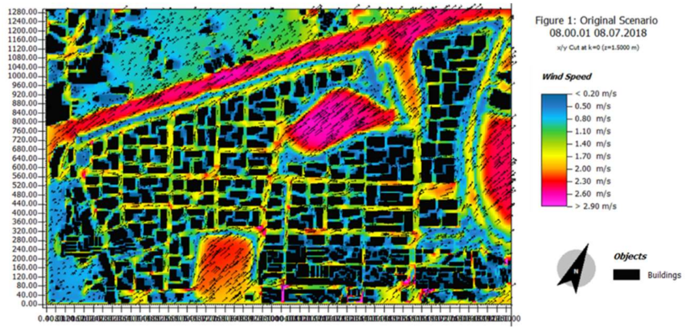

Figure 2

This study is also useful as it highlights the importance of systematic scenario construction for exploring the effects of parameter variations on wind field simulation. This information can guide me in setting up different scenarios in my Unity-based CFD simulation to analyse how changes in urban morphology affect the wind flow. Another reason I included this paper is because of its discussion on Building Density (BD) and the coefficient of variation for building height are explored as additional indicators influencing wind field construction. This will be helpful as I want to investigate changes in wind flow accuracy when BD changes. A limitation of this paper is that it uses external software for the CFD, which cannot be use in my implementation.

### Z. Kaseb, “A framework for pedestrian-level wind conditions improvement in urban areas: CFD simulation and optimization”

This paper presents an evolutionary-based framework to optimize building heights and plan area densities to improve wind conditions in complex urban areas [1]. In this study, 3D steady Reynolds-averaged Navier-Stokes (RANS) CFD simulations are performed for generated urban areas.  RANS equations contain Navier Stokes equations but also offer a way to model turbulence by breaking down flow properties into time average values and fluctuations. The paper also discusses methods for validating the CFD algorithms. The CFD simulation used in this paper is proven to be accurate, but it is mentioned to have significant computation time (12 days on a personal computer). Whilst my project aims to produce an accurate wind simulation, which this paper’s CFD simulation could provide, another objective is to provide an accessible simulation; the computation this specific algorithm requires may make it unsuitable. Therefore, other papers were also considered.

A good thing about this paper is that it provides helpful discussion on validating CFD algorithms which was valuable, as one of my objectives was to validate my fluid solver algorithm. A downside of this paper is that the evolutionary based framework is very specific. While the explanation on validating the CFD algorithm is useful the rest of the framework cannot be applied to this project.

### Y. Xiao, et al., "Effects of inflow conditions on mountainous/urban wind environment simulation"

This paper [9] focuses on simulating wind environments in Hong Kong's Kowloon Bay coastal town, addressing inflow conditions for mountainous/urban areas. Two approaches, the IMP (Integrated Mesoscale-Flow Perturbation) and FEP (Filtered Eddy Perturbation) methods, are compared and validated against field data. IMP and FED are methods used to determine inflow conditions, which help dictate how a fluid behave when it enters a CFD simulation. The study investigates the trade-off between accuracy and computational efficiency.

The validation and comparison of the IMP and FEP methods in the paper offer insights into the methodology of effectively comparing algorithms, which will be help me accurately compare CFD algorithms in this project. It also provides further insight into the steps of simulating wind flow in an urban environment. Lastly, the studies investigation between accuracy and computational efficiency will help me achieve my objective, investigating wind flow accuracy against performance. However, this paper uses measured field date to validate the CFD approaches, so the method of comparing the two approaches is useful, but the validation techniques used are not applicable to this project.

### M. Tutar And G. Oguz, "Computational modelling of wind flow around a group of buildings”

M. Tutar and G. Oguz address the significance of numerical methods in understanding wind flow around buildings [10]. The study compares simulation results with experimental data, aiming to provide a more realistic description of flow fields and improve understanding of wind effects on various building models.

A positive of this paper is that it’s focus on wind flow around buildings will be useful for my project, as its use of specific boundary conditions gives me a good idea on how I can begin to implement them in my simulation. A downside of this paper is that it does not focus much on implementing CFD for wind simulations of urban environments so will not be very helpful in that regard.

### Jon Stam “Real-Time Fluid Dynamics for Games”

Jon Stam’s paper on real time fluid dynamics [4] provides a rapid, just-in-time implementation of a CFD solver using the Navier Stokes equations (NSE). The foundation of many CFD simulations are the NSE, which describe fluid motion. The implementation provided is a 2D fluid solver coded in C, specifically designed for use in game engines to provided more realistic fluid simulations in real time games.

This paper was worth considering for my project as it discusses an implementation of a fluid solver which focuses on efficiency, which is what I aim to provide in my project. However, its implementation is neither in the context of wind in an urban scenario, nor provides effective ways to validate the algorithm. This is a limitation of this paper as it cannot be determined if the solver the paper provides produces an accurate wind simulation.

## Choice of fluid solver

It was clear from research that the implementation would need to involve CFD to accurately calculate the wind flow. My project needed to use a CFD solver as framework to build upon, as building a CFD solver from scratch is a significant task which is not something that could be done in the projects time frame. I had to consider the pros and cons of each CFD implementation the discussed papers provided, then chose a fluid solver to implement and extend.

|  |  |  |
| --- | --- | --- |
| **Paper** | **Method** | **Pros and Cons** |
| Evaluating the Influence of Urban Morphology on Urban Wind Environment Based on Computational Fluid Dynamics Simulation [5] | Uses commercial software called ENVI-met to simulate wind flow using CFD. | Pro - commercial software, so ensured validity of CFD simulation.  Con - software still suffers from a steep learning curve to understand how to properly set up the simulation  Con - high computational costs due to the equations used to calculate the fluid flow.  Con - I would not be able to improve the software as I cannot access the code and the paper does not discuss the algorithms the external software uses. |
| A framework for pedestrian-level wind conditions improvement in urban areas: CFD simulation and optimization [1] | 3D Steady RANS equations used for CFD simulation. | Pro - proven to produce accurate wind flow simulations  Con - significant computational cost (12 days on a standard computer).  Con – equations are complex, and the algorithm/implementation is not discussed. |
| Real-Time Fluid Dynamics for Games [4] | NSE used for CFD simulation. | Pro - solves the NSE in an efficient way suitable for real time.  Pro - implementation of the algorithm is discussed, and the algorithm is available.  Con - may not produce accurate wind flow as the paper provides no discussion on validation.  Con – solver is not in the context of wind.  Con - implementation is 2D, while wind flow around buildings is inherently three-dimensional. Extending this approach to 3D would likely increase complexity and computational cost. |

It was my initial plan in the project proposal to use RANS equations to make my solver, as they were proven to be accurate. However, these equations are complex and require a lot of computation as mentioned before. A consideration was made into pre-computing the equations so that the visualisations could still be displayed in real time, but this would not avoid the computation time if architects wanted to produce a simulation for a new urban area. Although the implementation of the RANS equations is not discussed, an attempt could be made to implement the equations using numerical analysis. The most accurate solution would be the Runge-Kutta method [11]. However, this was also a problem as attempting to convert the equations into code would take a significant amount of time and understanding; reducing the computation to produce an accessible simulation might not even be possible. With the time constraints of the project, I decided not to pursue this.

Since I was focusing on efficiency to make the simulation more accessible, and working within a tight timeframe, the decision was made to try and adapt Jon Stam’s fluid solver [4] to accurately simulate wind in urban areas. As it is capable of solving the NSE in a stable way and fast enough to be simulated in real time, allowing the simulation to be accessed by anyone. The original algorithm is also available so it can be adapted into a 3D simulation of wind flow in an urban area, helping my complete the project in the time constraints.

However, the accuracy of the fluid solver is a problem as the paper provides no discussion on validation, because it is a white paper and not one from an acclaimed conference. This means it is integral that validation is performed on the wind simulation this project produces, to ensure that it does simulate accurate wind flow so that it can provided useful data to architects and engineers. If using Jon Stam’s solver [4] as a framework for my wind simulation does not provide accurate wind flow, another solver will have to be used and the real time aspect will have to be scrapped.

## Why Computational fluid dynamics is necessary

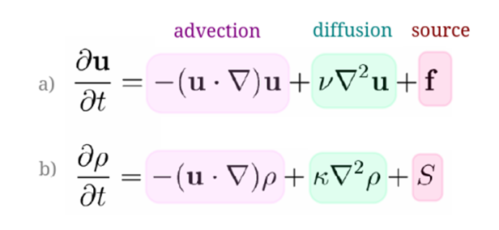The Navier-Stokes Equations are the fundamental equations that govern how fluids behave, and they are widely used in CFD simulations. The incompressible NSE can be represented as follows:

Figure 3

Where **u** is the velocity vector, **ν** is the viscosity of the fluid, and **f** is the external force acting on the ﬂuid. The differential terms in the Navier-Stokes equations are approximated using finite difference methods, making them suitable for computation. In the fluid solver, specific function are implemented to allow for the simulation of wind flow. I will explain why they are needed:

In CFD, the advection step represents the fundamental process of how a quantity within the fluid is moved along by the flow. In this case the quantity that is moved along through the flow field is the winds velocity. Without this function implemented, the wind simulation would be static. To accomplish advection, a linear backtrace is used to calculate how each velocity has moved from a previous location. Backtracing is used as opposed to tracing forward in time as it guarantees that the simulation does not artificially lose or gain density by ensuring particles always land on existing grid positions. Whereas with tracing forward in time, some grid cells might not receive any particles, which would cause gaps in the simulation.

Projection is needed in the wind simulation because when solving the NSE, small errors can accumulate over time, which could cause the wind simulation to produce unrealistic effects such as not being divergence free and violating the incompressibility condition. Therefore, the goal of the project function is to modify the velocity field to enforce incompressibility (mass conservation). To help meet my main objective in producing an accurate wind simulation, this step is necessary.

Diffusion represents the natural tendency of a quantity (like dye in water) to spread out from an area of high concentration to low concentration. A controlled amount of diffusion in the simulation, helps to prevent unrealistic spikes or oscillations in velocity. This enhances the stability and realism of the wind simulation. The diffusion of a fluid is dependent on its viscosity. The viscosity of air is highly dependent on temperature but at 15℃ it is 1.48 x 10^-5 m^2/s [12]; this is the value that is used in my simulations as this is the average air temperature of earth. But it can easily be adjusted for different temperatures.

# Implementation

In this section the implementation of my fluid simulation in the Unity game engine will be discussed. The design process and how the key features of the project were implemented will also be outlined.

## Ethical considerations

While there were no ethical problems found during the background research or project planning stages, it was still critical to continue paying attention to any possible ethical issues that could arise. Every step of the research and development process was continuously cross-referenced with the ethics checklist as the project progressed.

The project's integrity and ethical soundness were upheld throughout its development due to the iterative ethical review, open communication, and adherence to ethical best practices. Overall, no ethical concerns were raised during this project’s development.

## Fluid simulation

As stated before, Jon Stam’s solver [4] was used as a framework for my solver. Before the adaptations could be attempted, I needed to make sure I fully understood how the solver I intended to use worked. Since the NSE are complex equations which I had no previous exposure to, a lot of time was spent examining Stam’s code to gain an understanding on how it works. This was an important task, as this solver is the core of which my project is built on, so an incomplete understanding could lead to incorrect adaptations and extensions. Once I felt the equations were fully understood, I moved on to adapting Stam’s solver [4].

I had to adapt Stam’s solver [4] in many ways to enable the simulation of wind flow through urban areas. The changes I have made firstly include a conversion of the code into C# (specifically for unity) and an expansion into 3D. This required new arrays, additional for-loops in the functions, and an extension to all the calculations, to account for the extra dimension and the addition of buildings. Secondly, the boundary condition function needed reworking as Stam’s original solver [4] simulated fluids in a container. This is not suitable for this project, as wind needs to be able to flow freely in and out of the urban area; a contained simulation space will not allow this to happen. Furthermore, the solver was adapted through the addition of internal boundaries in the flow to simulate the buildings and their effect on the wind. This is an important feature as wind flow in an urban area is mainly determined by how it interacts with buildings. Lastly, optimisations to the original algorithm have been made, such as using more efficient data structures and abstraction of repeated code into individual functions to improve the codes readability.

To avoid repetition, I will outline the main parameters of the simulation first:

* N (grid size) - Grid size dictates the simulation's spatial detail: finer grids mean each cell represents a smaller piece of the simulated world, allowing for higher resolution. N also determines the size of the velocity and building arrays. N is the size of the x and z axis and yN is the size of the y axis. A separate value for y is used, so it can be varied as needed to improve performance through less grids.
* Iter (iterations) - The Gauss-Seidel solver has a variable iteration count: more iterations result in a more accurate wind flow [13].
* Dt (fixed time-step) – represents the amount of simulated time between each update of the fluid solver.

There are also the data structures which contain the velocity field (Vel, PreVel). These are 3D arrays of floats for the x, y, and z velocities and previous velocities. Two arrays for each velocity vector are needed as previous velocity values are essential for the advection step and are used as temporary storage.

A consideration was made between using floats and Unity’s Vector3 structs, as using Vector3 structs would reduce the number of arrays needed, improving the codes readability. However, since we are accessing the x, y, and z velocity values thousands of times each update, this would technically involve individual function calls if Vector3 structs were used. This would be slightly less efficient than directly accessing float array elements (8-9% slower [14]). Therefore, the design decision was made to use floats instead, as the direct access that three separate arrays of floats provide is likely to be faster. Which is important in trying to produce a simulation which focuses on performance.

Stam’s implementation also used a 1D array for each velocity value (x, y, z) [4]. However, this required an extra indexing function to then find the values position in the grid; it also reduced the readability of the code. Therefore, the decision was made to use tensors for my simulation as this eliminated the need for a separate indexing function, it also significantly increased the readability of the code.

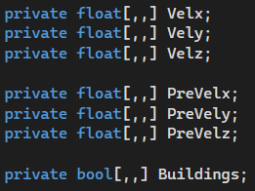Lastly, I used a 3D array of Boolean values to contain the grid cells in which buildings occupy. The decision was made to use the same data structure as the velocity values, as this would make it easier to calculate which cells contained a building, because they can be referenced with the same coordinates. A value of 1 (true) means there is a building or part of a building in that cell. These arrays can be seen in Figure 4.

Figure 4

### Fluid solver - Main loop

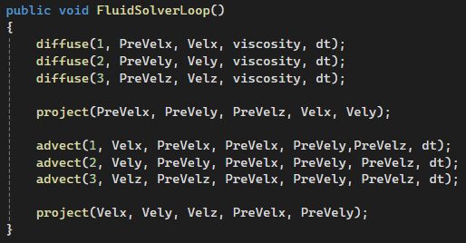

Figure 5

Going back to the NSE in Figure 3, these equations can be interpreted as saying, the velocity over a time step (dt) changes due to three main factors: viscous diffusion, self-advection, and the addition of forces. I chose to add forces in a separate function. But the main fluid solver loop seen in Figure 5 accounts for the other factors. The diffuse function is called three times for each dimension. Then project is called to keep it mass conserving. The advect function is then called three times for each dimension, and finally project is called again to ensure it remains mass conserving. This function is called in Unity’s update function, which is called every frame. Allowing for the real time simulation of wind through an urban area.

Each step (advection, diffusion, projection and add forces) will be explained in the following sections as to how it works, and the technologies used to implement them. The main functions in the 2D and 3D fluid solvers contain almost the same code, apart from extensions made to account for the extra dimension. To avoid repetition, only the 3D functions of the fluid solver will be discussed in the further sections on the code, although their functionality is the same.

### Advect

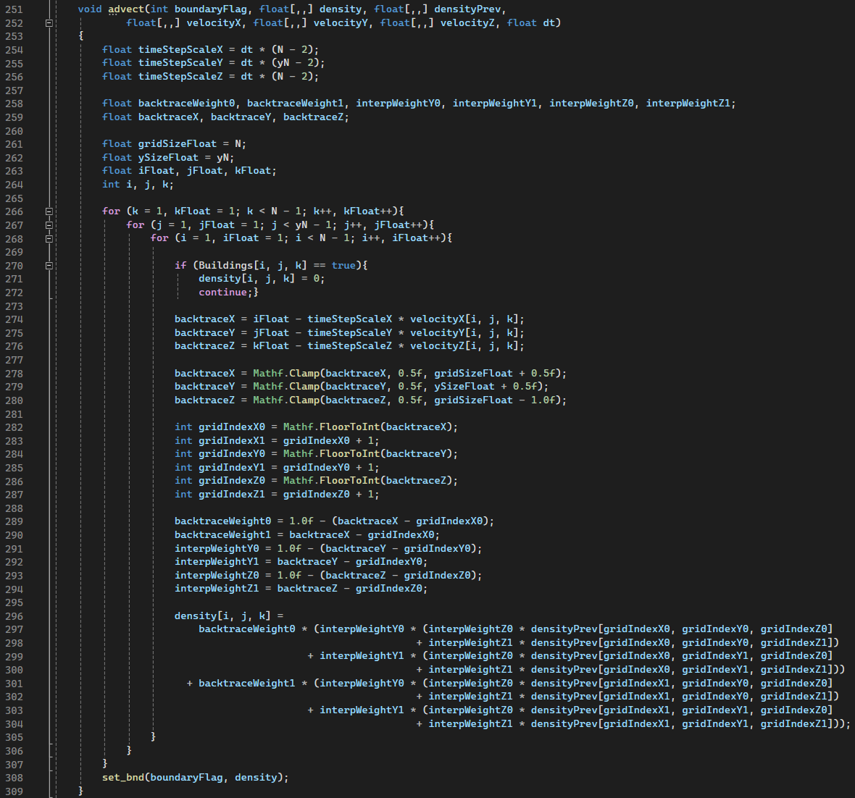The advect function works as follows (Figure 6):

Figure 6

It first calculates the time step scale values in lines 254-256. This calculates how much to scale the velocity, based on the grid size (N) and the time step (dt). These values will determine how far to trace back in time.

The function then iterates through each cell in the 3D grid, with 3 nested loops: one for each dimension. Inside the loops the first thing the function checks is if the cell in the 3D grid contains a building (270). This check is not something that was initially considered, and originally the wind speed and direction for building squares was resolved in the boundary condition function. However, when testing the performance of the simulation with increasing building density, I noticed a decline in run time as building density increased (these results are discussed further in the evaluation section). Therefore, I decided to try to optimise the algorithm so that it skips the large calculations in the cells which contain a building, as calculating wind speed and direction are not necessary here. It quickly became apparent that a simple check to see if the current cell contained a building would work. If the cell does contain a building, the large calculations are skipped, and the function moves onto the next coordinates.

The next part of the function uses the previously calculated time step scales to find how far to trace back, based on the velocity at the current cell. The coordinate that is reached by tracing backwards is found (274-276). Several checks have been added to make sure the coordinate is inside the grids bounds to prevent errors. This is done with the Mathf.Clamp function (278-280). These checks needed refining from Stam’s original solver [4], as I found that for higher wind speeds, out of bounds errors still occurred. Since my optimisations, higher wind speeds can now be used without causing out of bounds errors.

Lines 282-287 find the integer indices of the grid cell the backtraced point falls into, along with the neighbouring cells indices which are needed for interpolation. The integer indices are needed as opposed to floats, because grid cells need to be referenced with integers. In lines 289-294 the interpolation weights are calculated to determine how much the velocity values from surrounding grid cells should contribute to the current cell's new velocity. The interpolation weights are calculated based on how close the traced point is to the surrounding grid cells.

The last part of the advect function is the interpolation (296-304). The calculation performs the trilinear interpolation. Taking a weighted average of the previous time steps’ values surrounding the traced back coordinate, giving the approximate value at the location the fluid came from. This interpolated value is then assigned to the current grid cell.

Finally, a call is made to the set boundary function after all the grid cells have been updated, this function will be described separately but it mainly ensures that buildings are properly accounted for.

### Diffuse

The diffuse function simply works as follows (Figure 7):

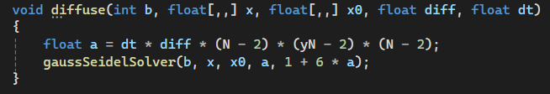

Figure 7

It calculates a diffusion coefficient based on the simulations’ time step (dt), the diffusion parameter (viscosity), and the grid dimensions. A call is then made to the Gauss-Seidel iterative solver to perform the actual diffusion calculations.

Stam used a Gauss-Seidel relaxation in his solver [4] but I had to consider if this was still the best method to solve the partial differential equations for my wind simulation. I found that iterative methods (such as Gauss-Seidel) are preferred in CFD as they are more efficient than direct methods that solve matrix equations exactly [15]. Since I am simulating in real time, efficiency is important, so this is also the solver I chose to use.

The Gauss-Seidle solver I implemented can be seen in Figure 8. It first precalculates the reciprocal of c (line 185), so the main calculation loop can be multiplied by cRecip instead of dividing by c each time. This was done because on most computer architectures, float multiplications are up to 5x faster than float divisions [16]. Since this calculation is being done for each grid cell this is a worthwhile optimisation over Stam’s original algorithm [4].

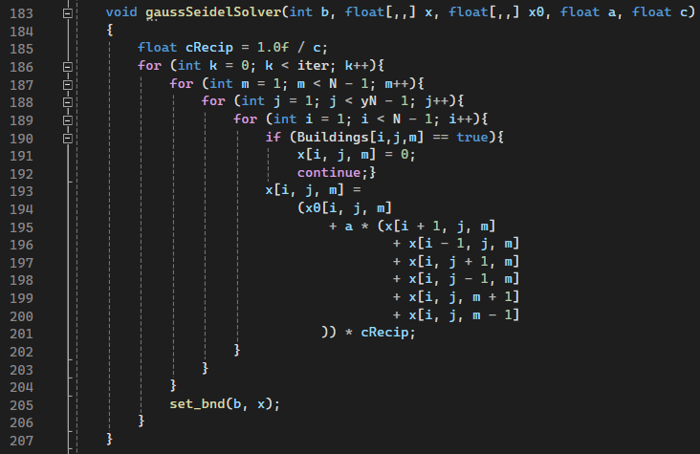

Figure 8

The rest of the solver works by iterating over each grid cell a number of times defined by iter (iterations). Then a check is made to see if the current cell contains a building, if it does it is skipped, as diffusion does not happen through solid objects. Then it calculates a new value at each cell (x) based on the previous value (x0), and the weighted sum of the values from the current cell’s neighbours. Lastly, the boundary conditions are enforced again.

### Project

For a velocity field to be divergence free there should be no areas where wind appears to be created or destroyed, unlike the right most image in Figure 9 – [17]. Therefore, the goal of the project function is to modify the velocity field to enforce incompressibility (mass conservation).

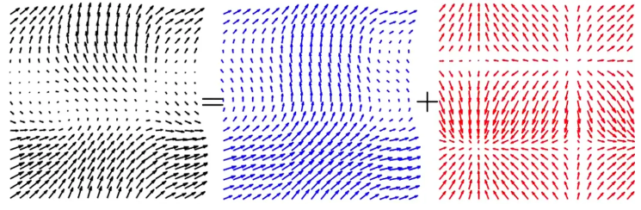

Figure 9 – [17]

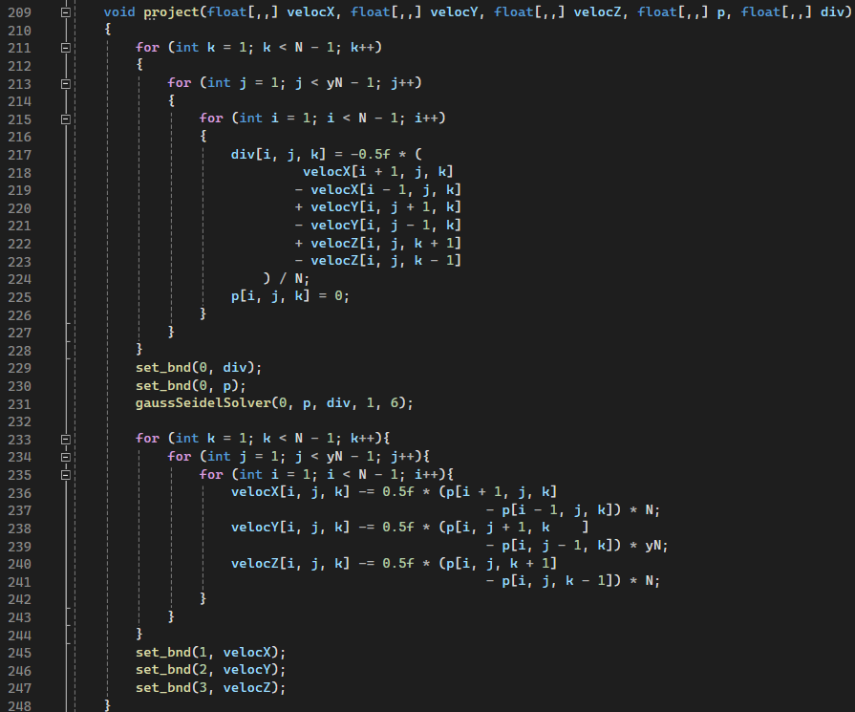To do this, a result from pure mathematics called the hodge decomposition is used: every velocity field is the sum of a mass conserving field and a gradient field [4]. This can be seen in Figure 9 – [17]. This means that the gradient field can be subtracted from the velocity field to get a mass conserving field which produces realistic wind patterns. The gradient field can be calculated by solving a linear system called a Poisson equation. The Gauss-Seidel relaxation step can be used again to solve this. Since I was reusing almost the same code, the design decision was made to self-contain the code in the function “gaussSeidelSolver”, adapting it to be used by both the project and advect functions. This was not considered in Stam’s solver [4].

Figure 10

The project function works as follows (Figure 10):

Using nested loops for each dimension, it first computes the divergence of the velocity field at each grid cell (div) using a finite difference approximation. The code calculates the difference between the velocity components on opposite sides of a grid cell. For example, lines 218-219 represents how much the flow is expanding or contracting in the X-direction. The differences in the X, Y, and Z directions are added together. This gives a measure of the net inflow or outflow at that cell. If the calculated divergence is non-zero, it signifies that the fluid simulation is not incompressible at that point. The rest of the project function aims to correct that.

The pressure field (p) is then set to zero to act as a starting point before it is calculated. p is a specific scalar field calculated during the projection method; its gradient is the part of the velocity field that needs to be removed to ensure mass conservation. Two calls to the set boundary function are made to ensure the calculations remain accurate within the simulation’s domain. The next call is to the aforementioned Gauss-Seidel solver, which is the key step to solving the discretized Poisson equation. Solving the pressure field (p) for the divergence field (div).

After the pressure field has been calculated, the x, y, and z velocity fields are then corrected based on the calculated pressure gradient; the scaling factors (N, yN) account for grid dimensions. As can be seen in lines 236-240, the pressure gradient field is subtracted from the velocity field, resulting in a mass conserving field which is divergence free. Producing a mass conserving wind simulation. Finally, boundary conditions are once again applied to the velocity arrays.

### Add forces

Another important consideration is how the wind flow is added to the simulation. This is not something directly covered in Stam’s solver [4] as the only addition of forces was to move a fluid around with the mouse. While using mouse movement to simulate the addition of wind is not suitable in my simulation, the method of adding forces is the same. As seen in the previously mentioned NSE (Figure 3), there is the addition of **f,** which is the external forces acting on a fluid. To then simulate wind flow, a force needs to be added, where the speed and direction can both be represented as a vector. In CFD the inflow condition defines speed and direction of the fluid as it enters the simulation, and the inlet is the physical boundary where the fluid enters the simulation. The inlet will be defined by a specific plane of the simulation space, as to accurately simulate wind flow over an urban area as a whole.

In my simulation the inflow condition is defined by the Add Velocity function. It takes a number of parameters, including two Boolean operators which determine the inlet plane the wind will enter from. I came to the conclusion that, only two planes are needed (z and x) to simulate all directions of wind flow as wind direction and building layout can be changed accordingly. To help visualise how the inlets vary for different planes, see Figure 11, where the inlet of the wind is coming from the z plane. There are also three floats which are passed into the function (amoutX, amountY, and amountZ), these represent the x, y, and z values of the velocity vector, meaning they control the speed 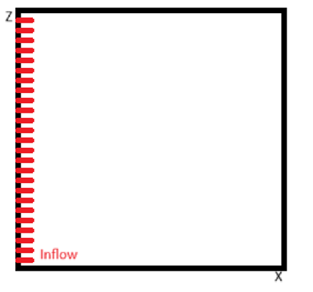and direction of the wind.

Figure 11

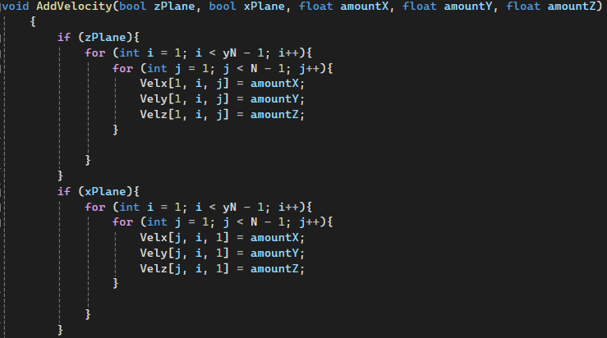The function works as follows, depending on which plane has been selected as the inlet (z or x), the function loops through all the gird cells on either the XY or ZY plane and sets the x, y, and z velocities at that point equal to the designated amount. Giving the specified grid cells a wind direction and speed. The code for this function can be seen in Figure 12.

Figure 12

It is worth noting that this function was called every frame in the update function, along with the fluid solver, however when no buildings are in the simulation, it would produce a completely laminar wind flow throughout the simulation. With the addition of buildings in the simulation, turbulence is produced, but wind on its own is naturally turbulent (produces irregular motions). This is a problem as it is clear from other CFD research that successful turbulence modelling greatly increases the quality of numerical simulations [17]. An attempt was made to implement a turbulence model, but it quickly became clear to me that this would require a whole new fluid solver to do so. RANS was found to be the turbulence model with the least computational cost [18]. However, RANS simulations can still take up to 5 hours to solve, even when the simulation is done on 2412 processors [19] or on a standard personal computer can take up to 12 days [1] . This is not at all suitable for real time computation and would not help me achieve my aim of providing an accessible piece of software: as the computational time or power required is not something all architects have and would limit the use of this software.

Therefore, to try and solve this problem I decided to test calling the Add Velocity function in fixed update. I noticed as this is called at fixed intervals as opposed to every frame, the addition of wind it not constant with the fluid solver, creating the effect of irregular gusts of wind, which worked and introduced a small amount of turbulence. This solution is not perfect, and it is an unfortunate limitation of this solver. In future work a possible solution would be to try and develop a turbulence model which works with the current fluid solver in real time. Unfortunately, this is not something I had the time to pursue with the time constrains of the project. However, as the validation in the results section proves, this wind simulation does produce accurate wind flow compared to wind tunnel results.

### Boundary conditions

In the real-world, wind flow problems have infinite domains, for example wind flowing through an urban area is not confined to just that area, it is able to freely enter and leave. CFD simulations, however, work on a finite grid representing a subset of physical space. Boundary conditions (BCs) define how the simulation interacts with the environment beyond this computational domain. The previously discussed Add Velocity function is an inflow condition, which is a type of BC. Other types of BCs include outflow conditions, which allow fluid flow to exit a simulation space and Wall BCs. These define how a fluid behaves when next to internal boundaries (such as buildings).

Therefore, to produce an accurate wind simulation, boundary conditions are necessary. Since the main aim of my project is simulating wind flow in an urban area, accurately setting the BCs for the buildings was the most important task, as it determines the accuracy of the whole simulation. In CFD, it is clear that for solid boundaries that are static, the no-slip BC is to be applied [20] [21]. Since buildings are solid and have no velocity, this BC applies here. The no-slip condition assumes that the velocity of a fluid at a boundary is equal to the velocity of that boundary. Since the buildings are not moving (have no velocity), the velocity of the fluid near the boundary of the buildings should be 0. The no-slip condition can be seen in Figure 13.

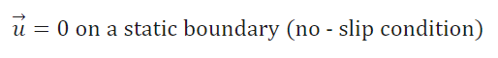

Figure 13

This BC was easy to implement since the 3D array that contains the building data is the same size as the 3D arrays for velocity. This meant that the gird cells which contained buildings could easily be used as coordinates for the velocity at that point. The implementation of the “set_bnd” (BC) function works as follows. The function takes two parameters, the first is an integer, which can either be 0, 1, 2, or 3. This integer lets the function know if it is dealing with something other than a velocity array (0) or if it is dealing with a velocity array (1,2,3); the values 1, 2, and 3 correspond to the x, y, and z velocity arrays accordingly. The second parameter is a 3D array. It then loops through all the grid cell coordinates, and for each grid cell location checks if there is a building there. If a building is found to be at that coordinate, the corresponding velocity at that boundary is set to 0. Testing was done to validate the boundary conditions and the wind simulation as a whole, it was found that it does produce accurate wind flow (validation can be found in the results section).

Another BC that seemed worth implementing to improve the accuracy of the wind simulation, was an outflow condition. This is because through testing the 3D simulation, I noticed that as the wind reached the downstream boundary of the simulation it would appear to curl around as if it was in a container. This should not be happening. Wind flow should be able to freely leave the simulation space, as it can in real life. Outflow conditions control how fluids leave a simulation space. An implementation of an outflow BC was attempted to fix this problem, where the outflow condition imposed a fully developed wind flow at the downstream boundary. It works by setting the outflow with the same parameters as the inflow. Therefore, an inflow condition with a velocity vector only in the x direction, would have an outflow like the code in Figure 14 (b==1 is the x velocity).

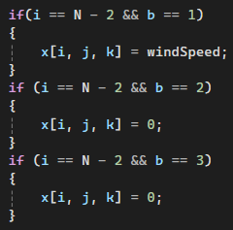

Figure 14

The outflow worked as expected and allowed wind to leave the simulation, however, it did not entirely fix the problem. Instead, it revealed that the problem was due to insufficient distance between the buildings and the outlet, not allowing the sufficient distance for the buildings wake (turbulence) to be resolved [22]. This was fixed by allowing enough space between the outlet and the main simulation space. This was done by increasing the simulation space. Research revealed that ensuring an inlet length of 5 times the inlet width, and an outlet length of 10 times the width allows for accurate simulation [23].

The longer outlet size made a visible difference to the simulation. In Figure 16 with the smaller outlet space, the wake/turbulence the buildings produce does not have enough space to resolve properly. Although accurate wind speeds within the urban area can be determined, the wind speeds downstream from the urban area cannot be inferred. In Figure 15 with the longer outlet, it can be seen that the wakes have enough room to resolve, allowing the downstream wind speeds to be accurately determined.

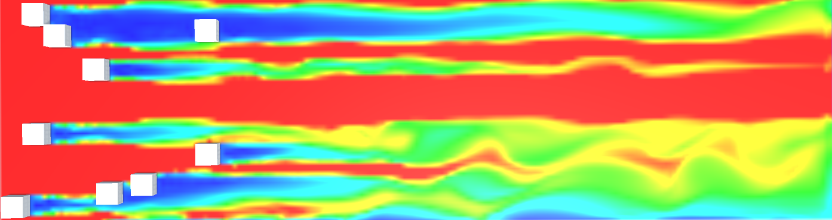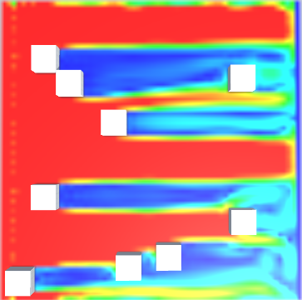

Figure 15

Figure 16

Overall, the BC function had to be completely changed from Stam’s [4], as his solver only considered the boundaries for a fluid in a container which is not applicable to my solver. My simulation required multiple different BCs to accurately simulate wind through an urban area, which I believe I have implemented effectively using the appropriate techniques.

## Visualisation techniques

An important development which I worked on alongside implementing the fluid solver was the visualisation techniques used to display the wind direction and speed. This needed to be developed alongside the fluid solver, as without the visual representation of the wind flow, it was impossible to tell if the fluid solver was working correctly. This meant a way to visualise the wind flow was key to the testing and development of the fluid solver. One of the main motivations for doing this project in the Unity game engine was that it provided a wide tool set of techniques to help me develop these visualisations. Game engines in general have already been recognised for their usefulness in visualising fluid flow [24]. This made development of good visualisations easier, which was necessary to help achieve my objectives in providing a useful and easy way of indicating the wind speed and direction. In this section the development process and implementation of the visualisation techniques will be outlined.

### Wind speed and direction texture

Development started with the idea of using Unity’s built in textures to display both the wind speed and direction on a single texture. The idea was to use the velocity vector of each grid cell and map it to the corresponding pixel on the texture. This would work as both the texture and the wind simulation work with a grid of coordinates. I decided to use the velocity vector’s direction (in the form of an angle) to decide the colour of the pixel, and the magnitude of the vector to decide the pixels brightness. While this visualisation helped to determine if the wind simulation was working, it did not provide a useful form of visualisation to help judge the differences in wind speed and direction. The code for this implementation can be seen in Figure 17.

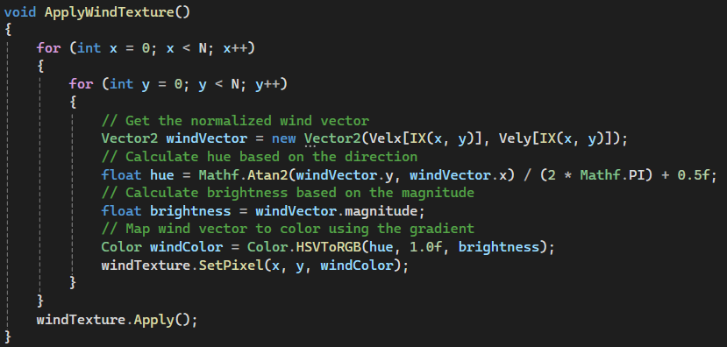

Figure 17

The results the wind texture produced can be seen in Figure 18. While it showed the wakes the buildings were producing, indicated by the colourful zones behind them (different colours meant different directions). It is hard to gain anything useful from the visualisation other than the fluid solver is working. Therefore, once I had got the wind simulation working, creating a new visualisation algorithm became my next priority.

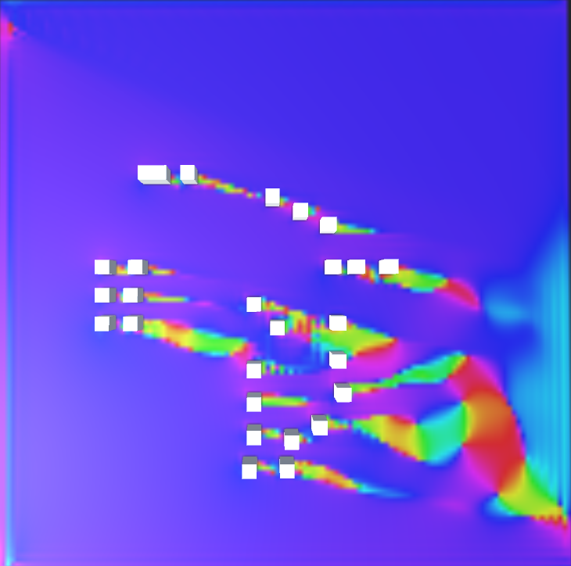

Figure 18

After testing multiple different texture implementations, I realised that displaying both the wind speed and direction on one texture may be possible for the 2D simulation. But the same technique would not work for 3D, as the extra dimension cannot be displayed on a 2D texture in a meaningful way. This required me to investigate other techniques to visualize both 2D and 3D vector fields. I found that representing the wind speed could still be done as before with textures. As other wind simulation software such as Sim Scale also visualises wind speed this way [25]. Visualising the winds direction required a different technique. I found that the most common way to visualise wind flow direction is by having arrows or glyphs to represent each vector in the field as a whole This technique is not only used to visualise general vector fields but also used by researchers visualising wind flow in urban areas [8]. Therefore, based on research, I decided to split my visualisation into two parts, a texture visualising wind speed, and a grid of arrows visualising wind direction.

### Wind speed texture

The first attempt at implementing a wind speed texture involved the same techniques as before. Getting the magnitude of the velocity vector at each gird cell and using the same coordinates to change the colour of the texture’s pixel at the point. The texture mapping worked as expected. The issue was with the method I used to determine the colour of the pixels. I simply calculated the vectors magnitude and used that value for the RGB value. This did produce different colours for different wind speed. However, it was not obvious what the colours meant, and it was hard to differentiate between them. What I needed was an easy-to-interpret visualisation. The idea of using a gradient of colours for different wind speeds was inspired from other wind simulation software [8]. The gradient of colours can be seen in Figure 19.

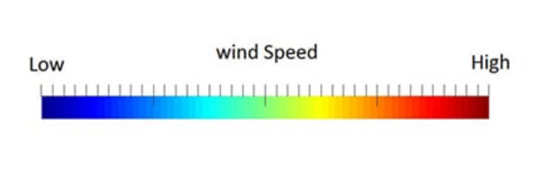

Figure 19

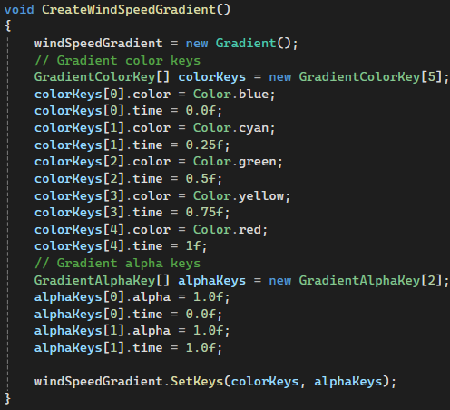Fortunately, the Unity game engine has a Gradient game object. This made implementing the wind speed gradient easy to do. The gradient is created in a single function. A new Gradient game object is made, which is then split into 5 different colours just like Figure 19. Each colour is assigned an equal percentage of the gradient. The code for this function can be seen in Figure 20. The wind speeds for each velocity vector can then be evaluated using a built-in function to determine where they lie on the gradient.

Figure 20

For the main wind speed texture function, it works as follows. Firstly, the y plane to be displayed is updated from the UI. The function then loops through all the x and z coordinates, and for each gird cell, the magnitude of the velocity vector is determined and evaluated with the wind speed gradient to determine its colour. The pixel at the same coordinates on the texture is then assigned that colour. The object displaying the texture is moved to the corresponding y plane, this was done to make 3D visualisation easier to interpret. Finally, the texture is updated with the new pixel colours. A check was also added to reduce computation; if a building is located on a grid cell, its colour is just set to black. The final code for this function can be seen in Figure 21.

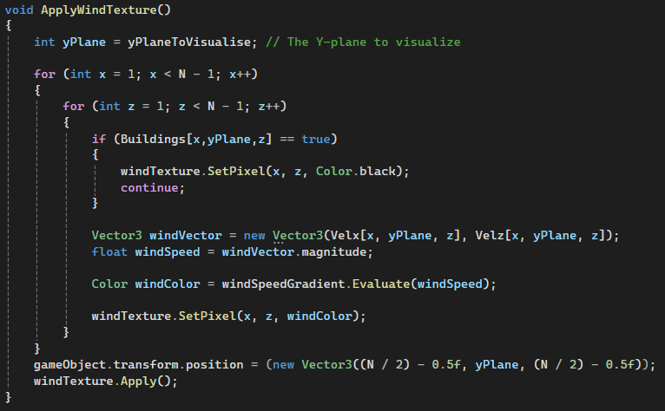

Figure 21

### Wind Direction with gizmos

As previously mentioned, I intended to implement an algorithm to display wind direction using a grid of arrows. I researched possible methods to do this, and the best solution I found was using gizmos in the Unity game engine. Gizmos are simple graphics objects which are usually used for debugging. However, since they can easily be used to draw lines on the screen in certain positions, I believed they would be suitable for the task.

The process began by first creating a simple function which looped through all the coordinates of the grid. A Vector3 object is then created for each grid cell, which is then used to determine the direction in which to draw the line. A separate Vector3 object is also created to store the position of where the arrows need to be drawn. Finally using a built-in function in Unity, the gizmo is drawn using the position and direction for each gird cell. The code for this version of the implementation is in Figure 22:

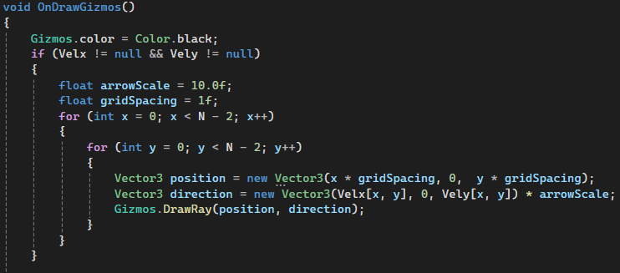

Figure 22

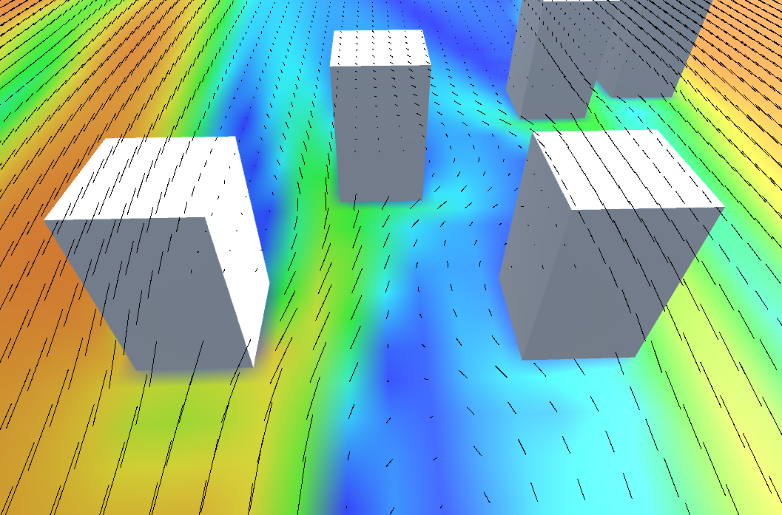This implementation worked well for the 2D simulation which it was first tested on. It allowed for a clear representation of the how the wind is flowing around the buildings. Furthermore, and unintended strength of this function is that it also acts as another method of visualising wind speed, as the gizmos have different lengths depending on the wind speed (larger arrow = higher wind), this can be seen in Figure 23. The reason the gizmos have different lengths is because the use of Vector3 objects does not just account for direction but also magnitude. This made the visualisations even easier to interpret and was deemed a successful implementation.

Figure 23

However, when this method was used for the 3D wind simulation it was hard to determine between all the lines with the extra dimension (Figure 26). This was not suitable in its current state, so to meet my objectives it needed to be improved. Taking into consideration other methods of visualising wind fields based on CFD simulations [8], my first improvement was to change the colour of the gizmo depending on the direction. This was harder to implement than I first though, as it was not as simple as taking the direction which has the largest weight in the vector. Because I found the starting direction of wind will dominate the other directions, meaning it will still all be one colour.

My solution was to check if the y direction had been affected first, as this was the direction buildings had the least effect on overall; if the wind is blowing in a y direction the gizmos are set to blue. The next step depends on the direction the wind flow starts form. If the wind is originally coming from the x direction, the z direction is checked next and vice versa. Assuming the wind was coming from the x direction, a check is made to see if it is now blowing in a z direction; if it is, then its set to green. Finally, if it is blowing in the x direction it is set to red. The code for this explanation can be seen in Figure 24:

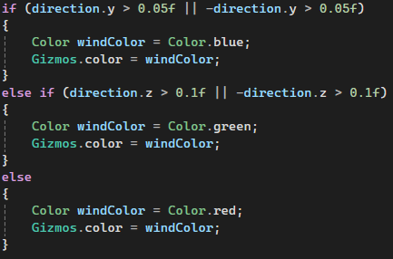

Figure 24

This implementation of colours definitely made it easier to differentiate between the gizmos and infer the direction of the wind flow. The improvement can be seen between the two algorithms in Figure 26 and Figure 25.

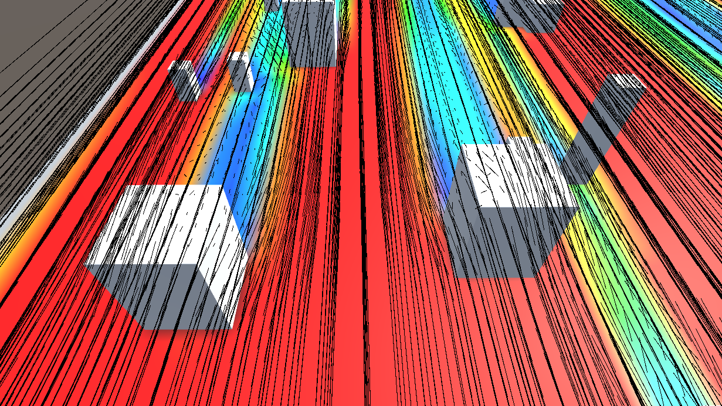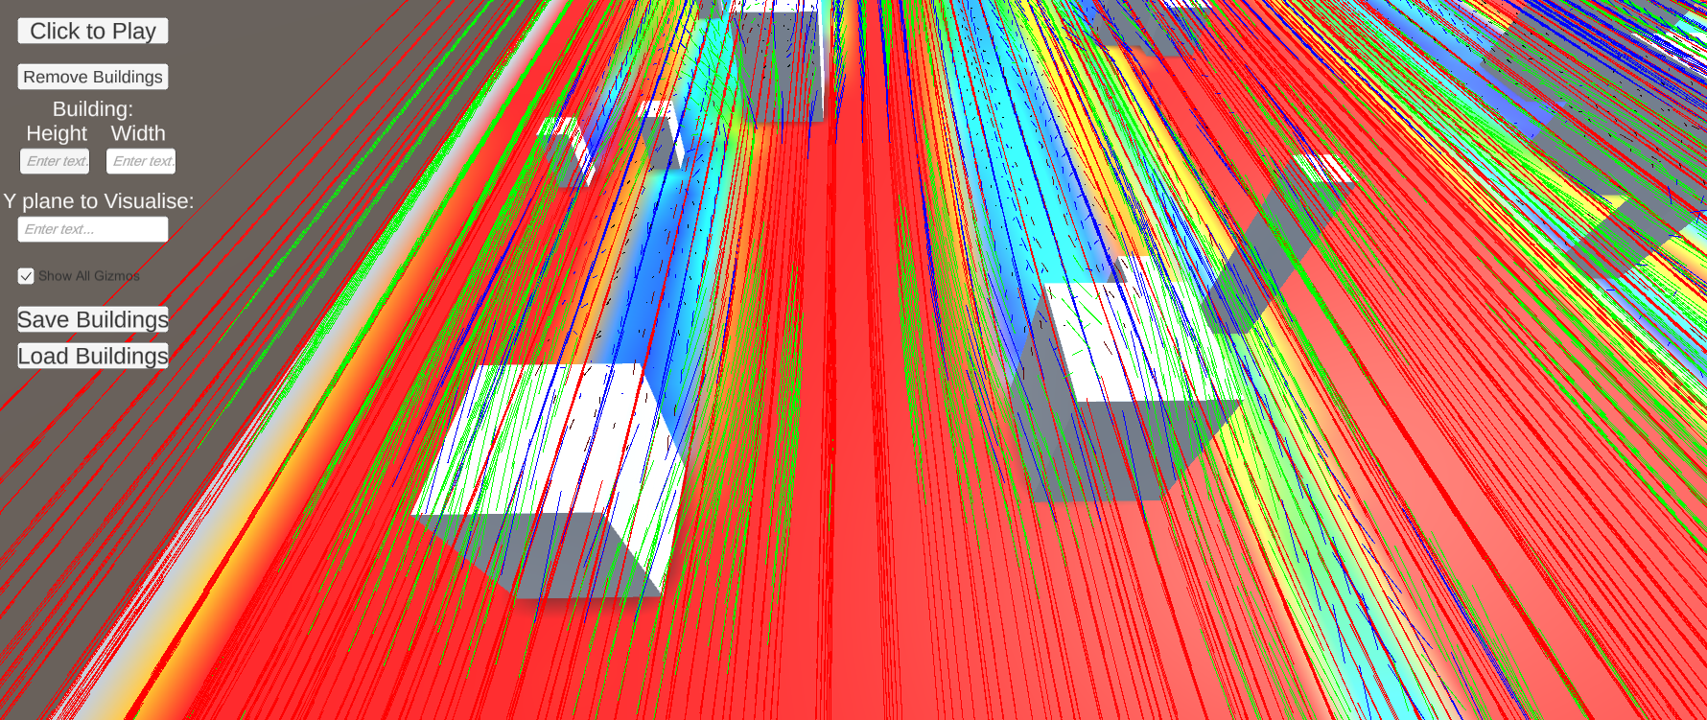

Figure 25

Figure 26

However, the screen is still very crowded, and it is still hard to work out the wind direction in some places. Also, the addition of the gizmos now makes it harder to infer the wind speed from the texture. I believed it could be further improved by only showing the gizmos around the buildings. This would make it less crowded, ensuring that it does not take away from the wind speed texture.

The option was added for users to switch between showing all the gizmos and only the ones around the buildings through the UI. This was implemented through the function in Figure 27.

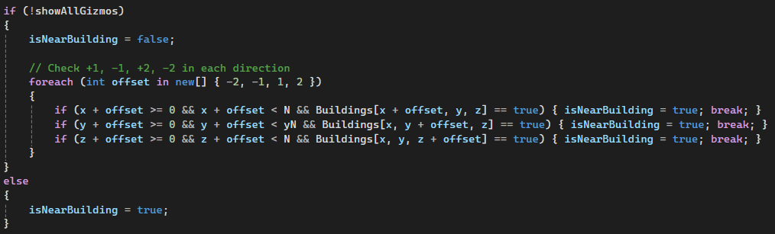

Figure 27

This function works by first checking which option the user has selected in the UI, if show all gizmos is true, then every grid cell is displayed by setting “isNearBuilding” to true. If show all gizmos is false, then only the grid cells within the range -2 - +2 of buildings are displayed.

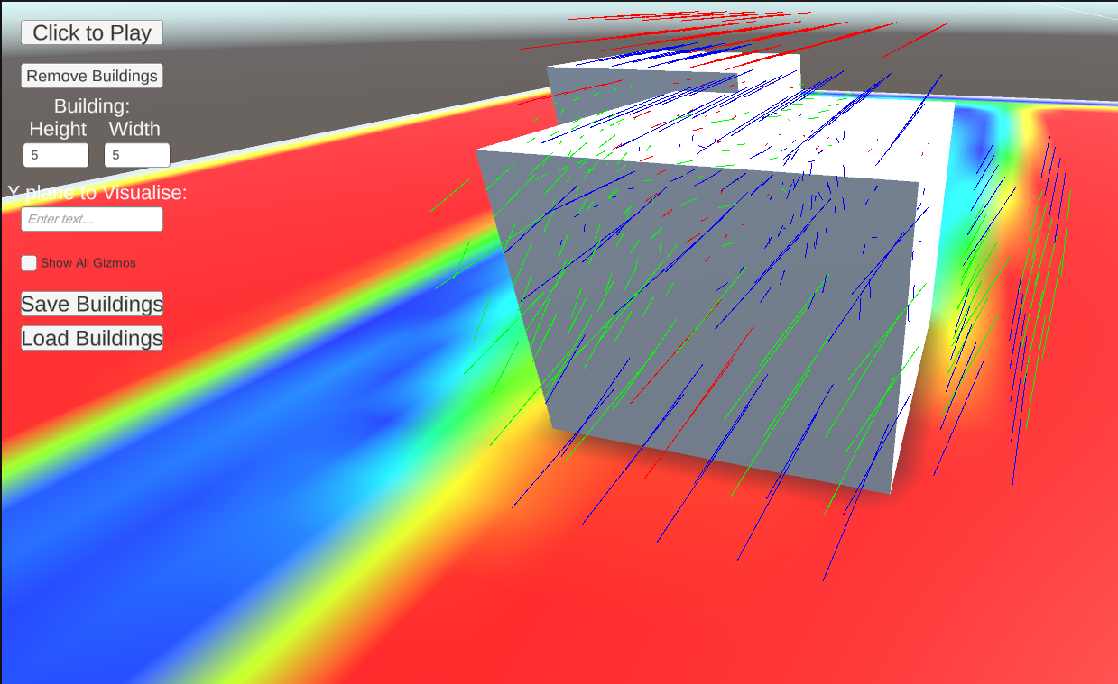

Figure 28

Figure 28 shows how much easier it is to determine the speed and direction of the wind flow with the gizmos and texture combined. The green lines indicating a change in the z direction, the blue lines indicating wind moving over the building and a downdraught. Lastly, the red line in the centre of the building, indicating the stagnation point.

# Results and Evaluation

## Grid density testing and evaluation

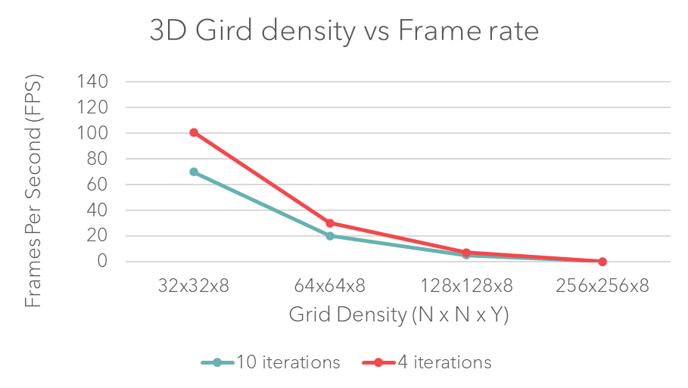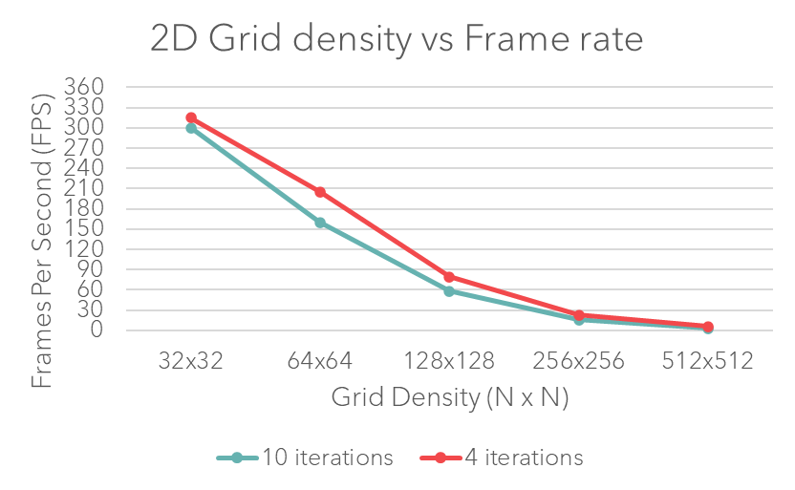In this part of the evaluation, I am testing to find the relationship between grid density in both the 2D and 3D simulations, and the fluid solvers run time. As stated in a blog on CFD meshing methods [26], “There is a trade-off between grid density, solution accuracy, and computation time. CFD simulations need to balance solution accuracy and computation time by adjusting the mesh density”. Therefore, it is important investigate this relationship and find the best balance.

Figure 29

Figure 30

A test was done which measured the simulation computation time (change in frame rate) as grid density increased. Changing the grid size allowed me to measure the grid density as the buildings in all the tests occupied the same amount of space. There were three buildings in the simulation for all the tests. Different tests were also done for 10 and 4 iterations of the Gauss Seidel iterative solver, as this also affects the simulations accuracy and performance.

As can be seen from the results above (Figure 30,Figure 29) the 2D solver can run at a stable frame rate up to a grid size of 256x256 but 512x512 does not produce an acceptable framerate. The number of iterations did not make much of a difference to performance of the 2D solver. The 3D solver, as expected, had worse performance due to the third dimension but can have an acceptable frame rate up to a grid size of 100x100 with a y value of 8. The number of iterations made more of a difference on the performance of the 3D solver. However, there was no noticeable difference in the wind simulation at 10 and 4 iterations, meaning the accuracy will be mostly unaffected. As discussed, increasing the grid density requires more computation, which negatively effects performance, but this evaluation is on the trade-off between computation time and solution accuracy. Therefore, testing also needs to be done to see how different grid densities effect accuracy.

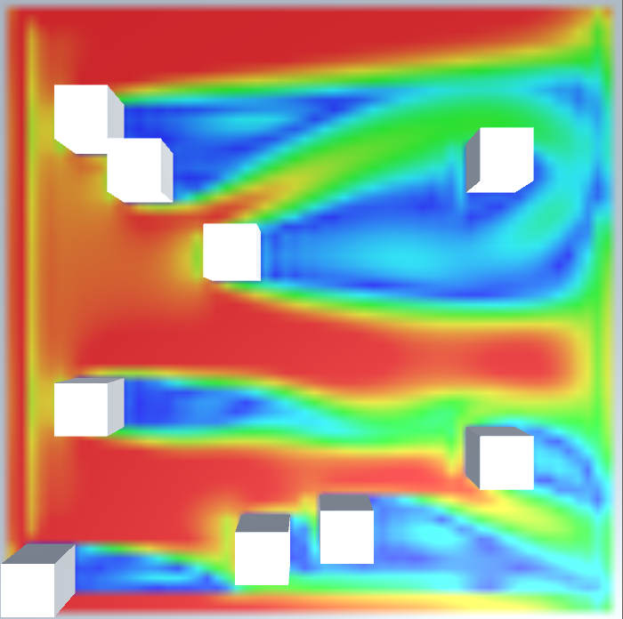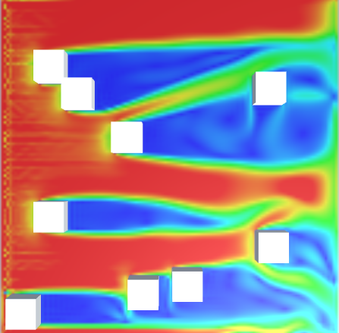

Figure 31

Figure 32

The two images above show the same urban area, but a different grid density was used for each simulation. The left image had a grid of 128x128 (Figure 32), and the right had a gird of 64x64 (Figure 31). As would be expected with more cells for the same area, the simulation with the higher grid density produced the most accurate wind flow. Another thing to be noted regarding my simulation is that with lower grid densities, the texture visualising the wind flow has a lower resolution. Making it harder judge the wind speeds in certain areas.

In CFD, there is a method to determine the optimal grid called the grid independence test [27]. It is used to find the optimal grid condition with the least grid cells, without generating a difference in the numerical results. The numerical results come from the evaluation of various grid conditions. The problem with this method is that there is no standardised method, and it depends on the researchers’ subjective needs and as to what they are simulating [27]. Therefore, depending on what users are using my software to simulate, it would be up to them to determine the grid density. For the most accurate results, the higher the grid density the better. However, as we have seen from previous results (Figure 30,Figure 29), there is a maximum grid size before the frame rate becomes too low.

To summarise, the 2D simulation has better performance than the 3D and can provide a higher accuracy due to being able to provide larger grid densities with a stable frame rate. However, accurately simulating wind flow patterns in urban areas requires more accuracy than the 2D simulation can provide. The 2D simulation can simulate wind speed but cannot accurately determine the wind direction. 3D models are a fundamental ingredient for designers to evaluate building layouts before construction [28]. This is because, 2D models do not consider the vertical profile of the wind so cannot simulate important wind patterns like downdraught [29]. Therefore, since these things cannot be approximated with my 2D simulation, the 3D simulation is preferred for accurately simulating wind flow through an urban area. As the benefits of the third dimension outweigh the additional overhead of simulating in 3D.

## Validating the wind simulation

The purpose of objective 2 is to ensure that my implementation for simulating wind produces realistic results, so it can be used as reliable piece of software for simulating wind flow through an urban environment. 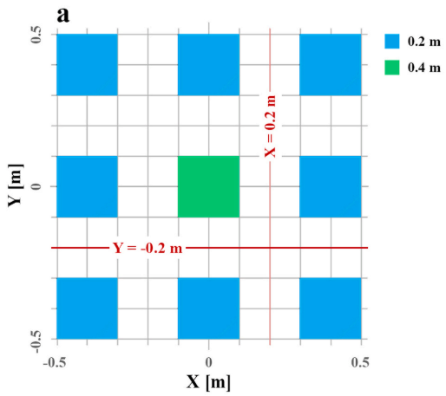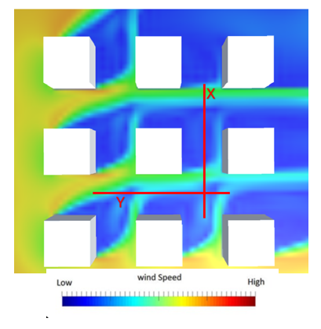To meet this objective, I validate my wind simulations’ accuracy by comparing my simulations results with wind-tunnel measurements from Nonomura et al [6]. I implemented a clear representation of the wind flow using textures to help me do this.

Figure 33

Figure 34

To realise this, I explicitly define the building layout as per [1]. A visualisation of the wind speeds is pictured on the left (Figure 33) and the top view of a reduced-scale generic urban area can be seen on the right (Figure 34); this was from a paper also using Nonomura’s experiment to validate their own wind simulation [1]. I have chosen to replicate this papers validation experiment as it is clear on details such as the wind speed and direction used; whereas the original experiment by Nonomura [6] lacks on specific experimental details. Although, Nonomura’s wind tunnel measurements are still used [6]. I have replicated the test with all the same parameters and the same scale model (1:1000). The wind direction was 22.5° and in Figure 35, Uref = 2.43 m/s (wind speed at H = 0.02 m) is used for normalisation. As I do not have access to a wind tunnel, my results will be compared to both the simulated results from “A framework for pedestrian-level wind conditions improvement in urban areas” [1] and the wind tunnel measurements from [6]. All the measured points are taken from the pedestrian level (y plane = 1).

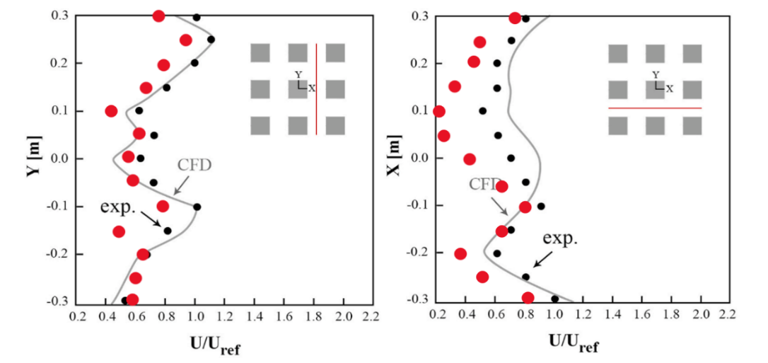

actual

actual

Figure 35

As can be seen from Figure 35, the original wind tunnel measurements are shown by the “exp.” points. The CFD results obtained from [1] can be seen by the line marked “CFD”. The results from my simulation are shown by the “actual” points marked in red. A good agreement can be seen between my measurements, and the ones from both the wind tunnel and previous study. The results in Figure 35 follow the pattern of both closely, however the mean wind speed measured from my simulation was lower than both the other measurements. This could possibly be because the time derivative (dt) used was different from the other CFD simulation, which could have affected the measurements. The paper in which I based the experiment on [1] did not include the dt they used in the CFD simulation, so I cannot replicate the same exact experiment. However, I used the exact wind speed value provided in their experimental set-up.

The results provided in the graphs (Figure 35) are reinforced by the figure showing the simulated wind speeds (Figure 33). For the results in Figure 35 showing the wind speeds along the line X = 0.2m, there are two spikes in the results (-0.1 and 0.25). These spikes in wind speed can also be seen on the texture showing the wind speeds, indicated by the two green sections along the x line (Figure 33). This also proves that the textures I implemented can provided an accurate representation of wind speeds in my wind simulation, making them a useful visualisation tool.

There was one anomaly which did not follow the trend of the other results. The measurement at -0.25Y[m] was less than the expected result, when it should have increased from the other measurements. The reason for this anomaly and as to why the other papers CFD results follow the wind tunnels more closely, is most likely because the equations that were used in their simulations are steady RANS. These equations are much more accurate but require significantly more computation, which cannot be done in real time. Since I am using Navier Stokes equations, small inaccuracies were expected.

I believe the validation proves that my simulation does produce accurate wind flow, as the results it produced closely followed wind tunnel measurements. This indicates that I have successfully met one of my main objectives (objective 2).

## Building density testing and evaluation

Part of the evaluation on the wind simulation was an investigation into how an increasing density of buildings in the simulation area effected factors such as the fluid solvers run time, memory usage, and simulation accuracy.

To help easily place lots of buildings and achieve a consistent increase in building density, a Bivariate Normal Distribution function was implemented [30] to randomly place buildings.

Figure 36 - probability density function [32]

The distribution parameters I used were dependant on the grid sized used, so the distribution is centred, and the spread (standard deviation) was a quarter of the grid size. Rho is 0, so buildings will be distributed independently in the x and y dimensions.

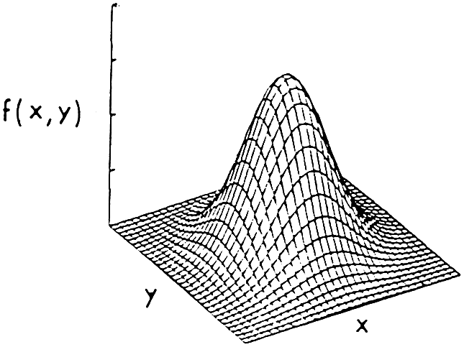The function takes x and y values (with the mentioned distribution parameters), and the Bivariate Normal Distribution function [30] calculates a probability density value at that point. The probability density can be evaluated for a range of x and y values and, when these densities are plotted in 3D space, it will visualise the characteristic bell-shaped curve associated with the Bivariate Normal Distribution (Figure 37).

Figure 37

This is suitable for quickly producing a large city layout of different densities as the simulation is working within a grid space, meaning the x and y values can easily be used as coordinates. The probability value can be used to scale the buildings’ heights, thus generating an urban environment with skyscrapers in the city centre and smaller buildings (such as houses or apartments) surrounding it. The reason this can also be used to alter the building density is because the probability value generated for each x and y can also be used as a probability for the buildings to be generated.

## Building density effect on simulation runtime

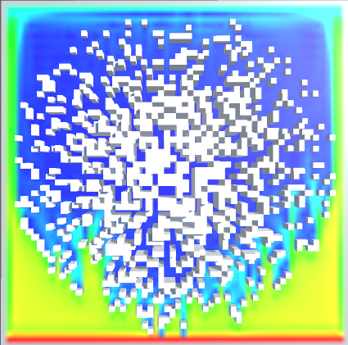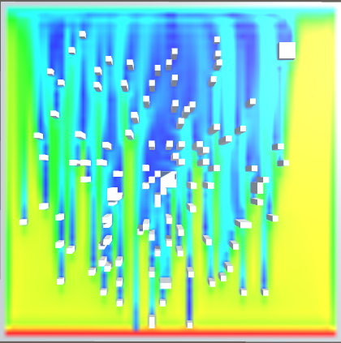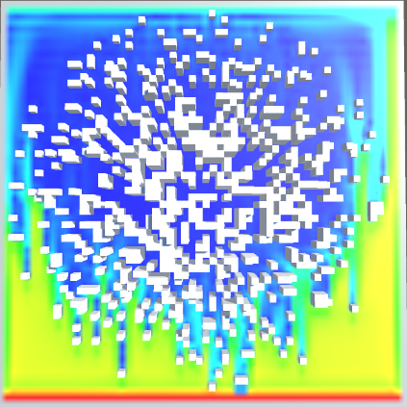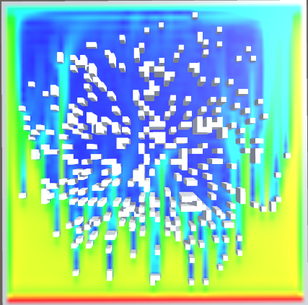The first evaluation done was against the simulation run time for the unoptimised algorithm. The P value is incremented from 0.1 to 0.7 to increase the building densities. Images to help visualise the different buildings densities in the simulation tests can be seen in the figures below (Figure 39 - P0.7, Figure 41 - P0.5, Figure 38 - P0.3, Figure 40 - P0.1). The lowest, and average frame rates are taken using a simple function that prints debug statements containing these values. The tests were done for at least 30 seconds each and the average was taken from multiple tests. The simulations parameters when the tests were completed were as follows: N = 64, yN = 10, iterations = 4. Since the wind simulator is called in the Update function (each frame), measuring the frame rate is an acceptable way to measure the effect on the simulations runtime.

Figure 38 - P0.3

Figure 39 - P0.7

Figure 40 - P0.1

Figure 41 - P0.5

As expected, the results for the unoptimized algorithm (Figure 42) showed a linear decline in the frame rate as building density increased. This will mainly be due to the fact with more buildings, more calculations are done at the boundary conditions, increasing the computational cost. It could also be due to the increased number of game objects in the scene at one time. However, since the optimisation worked, this is not the main factor influencing frame rate.

Figure 42

What was surprising is how little effect the increasing number of buildings had on frame rate. Each incrementation of P only decreased frame rate by roughly 1FPS each time. This is a positive sign as it shows the implemented boundary conditions for the buildings are efficient and do not bottleneck the original algorithm. One anomaly was that the highest FPS for P 0.7 was higher than P 0.5. This was consistent over multiple tests. The only possible cause I could think of is that with extremely high building densities there is less space between buildings, which could make the fluid simulation calculations easier in them spaces.

The unoptimised algorithm showed that increasing building density increased the simulation run time. This made me consider if there was a way to optimise the algorithm so that the simulation run time decreases as building density increases. I believed this would be possible as the grid cells in which the buildings occupy do not need wind flow to be calculated. Both the wind speed and direction on these cells can be set to zero instead of solving the Navier Stokes equations. This should reduce the overall computation time. These optimisations are discussed in the previous implementation section, but their performance shall be discussed here.

The results were measured in the same way, with the same parameters as the unoptimised algorithm. The results for the optimised algorithm can be seen in Figure 42 above, compared against the unoptimised algorithm. The optimisations made a noticeable improvement to the performance, increasing frame rate (decreasing simulation runtime) as building density increased. For P 0.1 the optimised algorithm has a slightly lower FPS than the unoptimized, this is probably because, the optimised algorithm adds extra checks in the hopes to avoid big computations, but with fewer buildings the extra checks end up slightly hindering performance.

Overall, there is an inverse correlation between the two algorithms. The optimised algorithms run time is faster than the unoptimised, with a building density of P 0.7 being 2.5 frame per second faster on average, and a higher lowest fps by 4 frames per second. Proving that it was the extra checks involved with more buildings that were increasing computation time and that these extra checks have been negated by skipping large computations where there are buildings. The improvement to the algorithm may seem small, but it means that the whole fluid simulation is more scalable. If someone wanted to increase the simulation space and add more buildings, they can do so without the worry of negatively effecting performance. This was deemed a successful optimisation.

## Building density effect on memory usage

During the same tests for simulation runtime above, tests were also performed to investigate how increasing building density affected memory usage. The parameters for the tests were the same as they were done at the same time. Memory usage was recorded using Unity’s memory profiler module. This allowed me to record memory usage in real time as the simulation was running. Figure 43 below shows the memory usage for the different density values. The object count (number of buildings) value in the figure reflects the increasing building density; object count increases as building density increases. This is because each building, no matter the size or shape, is made up of individual 1x1 blocks. Therefore, increasing building density requires more 1x1 blocks.

Figure 43

The results (Figure 43) show that as the building density increased the total memory used also increased. The test recorded memory while the simulation was running and while the simulation was completely off. This was done to properly evaluate the effect of the simulation with the memory usage. It was found that the memory usage increase remained almost the same (0.01GB difference) between the simulation running and being off. Indicating building density does not directly influence the memory usage, it is purely the number of building objects in the scene; if it was building density effecting the memory usage, we would expect a significant difference in results for the simulation being on and off. Instead, the increasing building density requires more building objects, and it is the building objects that are affecting memory usage.

Furthermore, the difference in memory usage between the simulation being on and off was consistently a 0.01GB increase. This most likely indicates that the simulation with its current parameters only uses an extra 0.01GB of memory regardless of the building density. Further indicating that the simulation does not require any more memory for differing building densities. However, the results do still show a linear increase in memory, which we now know is due to the amount of building objects.

The memory usage increase could be avoided by creating a single mesh object which represent the city/urban area, but due to time constrains and memory usage not being much of a concern I did not think it was necessary to implement this. However, if the simulation space was increased, the memory usage for higher building densities could be significant enough to make the simulation less accessible to people with smaller amount of memory on their PCs. This is a limitation of my simulation in its current state. A solution to this problem is discussed in the future work section.

## Building density effect on simulation accuracy

The last test done on the effects of building density is more of a qualitative evaluation on how the increasing building density effects the simulations accuracy.

The computational grid is the space in which the wind flow is determined and the space in which the buildings are placed. It is defined by grid cells. An important consideration for all fluid simulations is the grid spacing (the distance between each grid point). For more realistic wind simulations, a larger number of cells between buildings is needed to accurately simulate the wind flow. As building density increases the distance between the buildings decreases, making it harder and more computationally expensive to have enough cells between the buildings to accurately determine the wind flow. Testing the simulation so far has revealed that a minimum of two cells is needed between buildings to produce an accurate simulation.

In the tests, the grid size was 64x64x10. In the figures above (Figure 39 - P0.7, Figure 41 - P0.5) showing the different building densities for P 0.5 and 0.7, the buildings are too close together in the centre for completely accurate wind flow to be determined. This can be seen by the completely solid dark blue colour on the texture, indicating no/very low wind speed at that point. This clearly isn’t 100% accurate as there should be some wind flow through the city centre. This is due to the fact that with higher building densities, the number of grid cells between the buildings in the centre is either 0 or 1; not leaving enough space in-between to simulate the wind flow. As shown in the figures for the building density P 0.1 and 0.3, the wind speed is slower through the city centre but not zero (shown the by differing colours on the texture), meaning that the wind flow is being simulated as expected. In conclusion, for an accurate simulation of wind flow, the maximum building density should be between P0.3 and 0.5 to maintain enough grid cells between buildings.

## Correctness testing the 2D and 3D wind simulations

An important part of testing the wind simulation involved correctness testing the 2D and 3D wind simulations for different wind directions and strengths, to ensure the simulator can be used to accurately simulate wind for a variety of different variables.

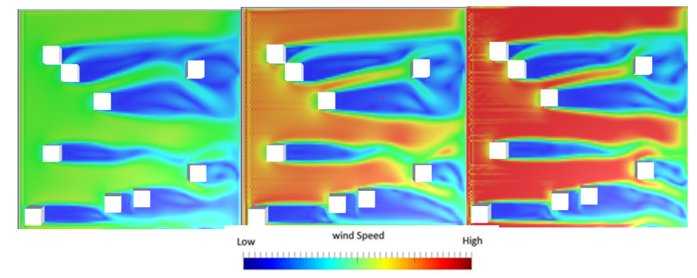The first tests correctness tests were done by varying wind speed for both the 2D, and 3D simulations. The tests were done with randomly place buildings to help better visualise the differing wind speeds and turbulence. The wind speeds used were 2.5m/s, 5m/s, and 10m/s. The visualisations of the different wind speeds can be seen in Figure 44 above.

Figure 44

Figure 45

From testing multiple different wind speeds and dt values, I found that performance was unaffected, and the simulation was able to perform for any wind speed or time step; Figure 45 below shows negligible difference in frame rate for different wind speeds. One thing to be noted is, unrealistic wind speeds produced seemingly unrealistic simulations (such as buildings having no effect on wind direction or speed). These simulations may still be accurate, but there is no way to verify this without a wind tunnel to compare measurements. Furthermore, I found that for low wind speeds, the visualisation of the wind speed it less useful as there is less variation in the colours for low and high velocities. However, this is not a bug; it is due to the fact the wind speed gradient has set values for low and high. Therefore, lower wind speeds use less of the gradient. A possible improvement to this is to allow the user to change the gradient min and max values, depending on the wind speed, to provide a more varied visualisation using the full gradient.

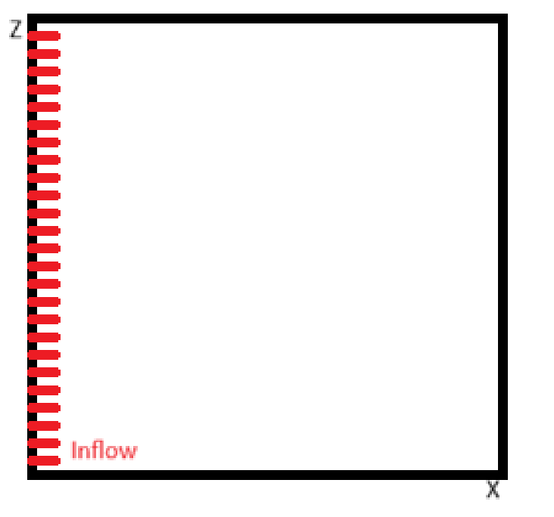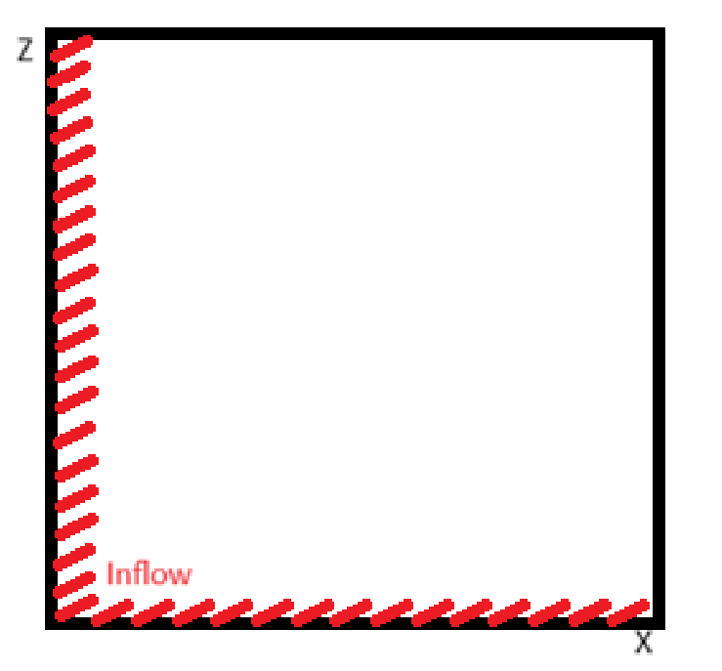The second test done examined what effects differing wind directions had on the simulation. Testing revealed that the simulation works as expected when the wind direction is straight or has slight angle (<20°), and when the inflow condition is only on one axis, like Figure 46 below.

Figure 46

Figure 47

However, when testing wind direction with a large angle (>20°), I realised I cannot use just one axis for the inflow, as this will leave a large area where there is no wind (which is unrealistic). So, I attempted to implement inflow from two different axis like in Figure 47 above. The test was using a setup like Figure 47.

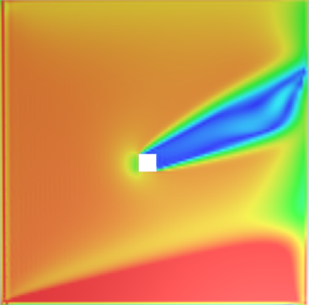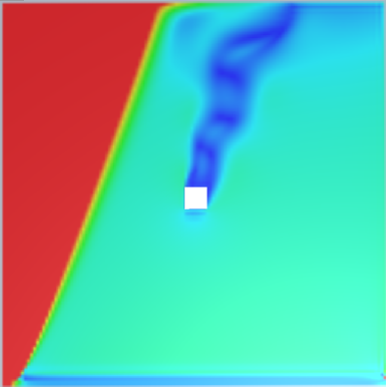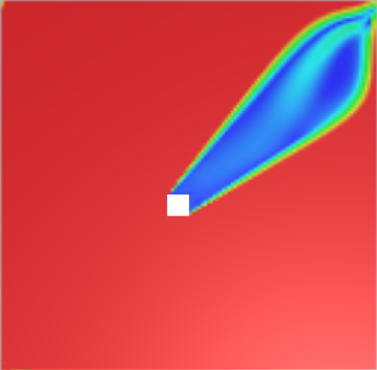

Figure 48 - 20°

Figure 49- 60°

Figure 50- 45°

Testing this implementation revealed a problem. The problem was that the inflow conditions on the different axis did not produce one direction of wind as expected. Instead, the two different inflow conditions seemed to interfere with each other, creating different wind speeds and directions. Figure 48 - 20°,Figure 50- 45°, and Figure 49- 60° show the different wind directions and the resulting wind flow patterns. Figure 48 - 20° produces an incorrect wind pattern at the bottom with a higher wind speed which can be seen by the red area. Figure 49- 60° also produces incorrect wind flow as can be seen by the two areas of very different wind speed. Both inflow conditions use the same velocity vectors so this should not be happening. For unknown reasons, the only wind direction that produced accurate wind flow, using two inflow conditions, was 45° (Figure 50- 45°).

This is not suitable for a simulation aiming to produce accurate wind flow. I tested multiple different inflow conditions, and to make sure the boundary conditions were not having an effect, I also tested with different boundary conditions. Nevertheless, the same inaccurate wind direction was being produced. After trying multiple different implementations of inflow conditions and boundary conditions, I was not able to solve this problem. This is a bug that remains in my code.

While this bug may be limiting, different wind directions can still be produced in a different way. Lots of different wind directions can still be simulated by either rotating the buildings or changing the axis the single inflow comes from. This is more difficult and time consuming than being able to use two axes to simulate the wind direction. Unfortunately, this is a limitation to my simulation as it means there are certain wind directions that cannot be simulated accurately. Therefore, it is not as easy to use as I intended it to be. I believe this problem could be solved by either parallelising the simulation or converting it to use the GPU through compute shaders. As it may be a concurrency issue which I could not solve, although it could also be due to another part of the algorithm. However, this is not something that I had the time to carry on investigating, nor did I have the time to try implementing a GPU based solution to test if this was the issue. This will be discussed further in the future work section.

# Conclusion

The main aim and objective of this project was to produce an interactive and accessible simulation that determines wind flow through an urban environment and allowed users to easily place buildings and designate wind direction and strength. I believe this project has met that objective. This is demonstrated by the simulation’s functionality in the evaluation, and through the correctness tests. The tests investigating performance against the grid density indicated that the 3D simulation is able to run at a stable frame rate on a personal computer up to a grid size of 100x100x8. This proves that an accessible simulation has been produced.

Objective 2 was to ensure that the simulation produced accurate wind flow through validation. This was also successfully achieved and proved that my simulation does produce accurate wind flow, as its results closely follow wind tunnel measurements [6].  While a minor discrepancy was observed, this was expected because of the focus on performance. The visualisations of the wind flow were also deemed successful as they further reinforced the validity of the results as seen in the validation section (Figure 33).

The third objective referred to testing and optimisation of the wind simulation algorithm. This has been met, as thorough testing was carried out comparing the 2D and 3D algorithms investigating the effect gird density has on performance and accuracy. Furthermore, effective optimisations were also carried out. Indicated by the FPS increase in using the optimised algorithm, over the unoptimised (Figure 42). The optimisation was carried out as completing objective 4 revealed that building density had a negative effect on performance, which was resolved through the optimisation.

## Future work

* When completing objective 4, a limitation of the project was revealed. It was found that due to the way the buildings are created, increasing the number of the buildings in the simulation directly increased the memory usage of the simulation. This is a problem, as for large cities the memory usage could become too high for some people to use; this would mean the simulation is not as accessible as I hoped. A possible solution for this problem is, in future work, changing the method for generating the buildings so that a single mesh represents the urban area instead of many objects. This would keep the number of objects in the scene consistent and stop the increasing memory usage.
* Another problem was revealed through correctness testing for objective 4. The method in which the wind direction is determined was found to be limited, and the fix that was attempted was unsuccessful. This meant the wind direction was more difficult to change than I had originally intended. I believed that this problem could be solved through parallelising the algorithm, but I did not have the time to attempt this. In future work, adapting the simulation to use parallel programming would make the simulation more efficient and hopefully easier to use though solving the wind direction problem.
* Lastly, while the simulation was found to produce accurate wind flow through validation, its main focus was on producing an efficient simulation that was more accessible. Other CFD software available will produce more accurate results, but as discussed this takes a lot of time to compute. My project is useful for people who want to simulate wind flow through an urban area quickly and easily. Potentially, it could be used as a first test to acquire rough results to see if a more complex and time consuming CFD simulation is worthwhile. In future work, and without the time constraints of the project, I would like to attempt to adapt more complex equations used in CFD such as RANS to be more efficient; resulting in software that can produce highly accurate results, whilst remaining accessible.

## Summary

To conclude, over the course of this project I had to dive into the world of CFD and research the various techniques used for simulating wind in an urban environment. Whilst challenging, I have managed to implement an efficient CFD solution for solving wind flow through an urban area using the NSE. Implementing the CFD solver provided a deeper understanding of the fundamental principles governing fluid behaviour. The iterative approach used to develop the visualisations was also crucial for interpreting the simulations results and helping to expose areas where improvements were needed. I have learnt that simulating fluid flow in real-time is a challenging task, and sacrifices have to be made, such as using more efficient CFD solvers at the cost of accuracy. In a field where the results can inform real world decisions, such as building placements, accuracy is more important than an accessible real-time simulation. Often, researchers prefer to use more complex equations such as RANS to achieve this. Nevertheless, this project highlights the potential of real-time CFD tools to inform urban design, whilst also underscoring the ongoing need for optimisation and accessibility.

# Bibliography

|  |  |
| --- | --- |
| [1] | M. H. M. T. a. S. D. Z. Kaseb, “A framework for pedestrian-level wind conditions improvement in urban areas: CFD simulation and optimization,” 2020. [Online]. Available: doi: https://doi.org/10.1016/j.builden. [Accessed 09 04 2024]. |
| [2] | “OpenFOAM,” [Online]. Available: https://www.openfoam.com/. [Accessed 26 04 2024]. |
| [3] | “Simulation Software | Engineering in the Cloud,” SimScale, [Online]. Available: https://www.simscale.com/. [Accessed 26 04 20204]. |
| [4] | J. Stam, “Real-Time Fluid Dynamics for Games,” *Alias Systems,* 2003. |
| [5] | C.-A. K. a. H.-K. Tsai, “Evaluating the Influence of Urban Morphology on Urban Wind Environment Based on Computational Fluid Dynamics Simulation,” *ISPRS International Journal of Geo-Information,* vol. 9, no. doi: 10.3390/ijgi, 2020. |
| [6] | Y. Nonomura, “The Cross Comparison of CFD Results for Flowfield Around Building Models (Part 3): the Wind Tunnel Test for the Varification Models on the Flowfield Around Building Blocks,” 2003. [Online]. Available: https://doi.org/10.14887/jaweam.2003.0.41.0. [Accessed 09 04 2024]. |
| [7] | M. B. a. V. Cristie, “CFD Post-processing in Unity3D,” *Procedia Computer Science,* vol. 51, no. doi: 10.1016/j.procs.2015.05.476., p. 2913–2922, 2015. |
| [8] | T. S. A. K. a. V. C. S. Schneider, “EXPLORING SCHEMES FOR VISUALIZING URBAN WIND FIELDS BASED ON CFD SIMULATIONS BY EMPLOYING OGC STANDARDS,” *ISPRS Annals of the Photogrammetry, Remote Sensing and Spatial Information Science,* Vols. VI-4-W2-2020, no. https://isprs-annals.copernicus.org/articles/VI-4-W2-2020/157/2020/isprs-annals-VI-4-W2-2020-157-2020.html, pp. 157-163, 2022. |
| [9] | S. Z. Y. X. Q. H. L. L. a. P. W. C. C. Li, “Effects of inflow conditions on mountainous/urban wind environment simulation,” *Build. Simul,* vol. 10, no. doi: 10.1007/s12273-017-0348-1, p. 573–588, 2017. |
| [10] | M. T. a. G. Oğuz, “Computational Modeling of Wind Flow Around a Group of Buildings,” *International Journal of Computational Fluid Dynamics,* vol. 18, no. doi: 10.1080/10618560412331291160, p. 651–670, 2004. |
| [11] | R. C. S. a. C.-C. Rossow, “An efficient solver for the RANS equations and a one-equation turbulence model,” *Computers & Fluids,* vol. 42, no. 10.1016/j.compfluid.2010.10.010, pp. 13-25, 2011. |
| [12] | C. C. Solutions, “The Relationship Between the Kinematic Viscosity of Air and Temperature,” [Online]. Available: https://resources.system-analysis.cadence.com/blog/msa2022-the-relationship-between-the-kinematic-viscosity-of-air-and-temperature. [Accessed 17 04 2024]. |
| [13] | S. Mazumder, “Numerical methods for partial differential equations: finite difference and finite volume methods.,” *Academic Press.,* 2016. |
| [14] | lordofduct, “Discussion - Structs are slow,” Unity Forum, 16 1 2023. [Online]. Available: https://forum.unity.com/threads/structs-are-slow.1387206/. [Accessed 25 04 2024]. |
| [15] | H. W. Chris Greenshields, “Notes on Computational Fluid Dynamics: General Principles,” CFD Direct, 11 04 2022. [Online]. Available: https://doc.cfd.direct/notes/cfd-general-principles/gauss-seidel-method/. [Accessed 17 04 2024]. |
| [16] | cppbenchmarks, “float division vs. multiplication speed,” c++ benchmarks, [Online]. Available: https://cppbenchmarks.wordpress.com/2020/11/10/float-division-vs-multiplication-speed/. [Accessed 17 04 2024]. |
| [17] | J. SODJA, “Turbulence models in CFD,” 03 2007. [Online]. Available: http://www-f1.ijs.si/~rudi/sola/Turbulence-models-in-CFD.pdf. [Accessed 18 04 2024]. |
| [18] | gestione, “Turbulence models in CFD - RANS, DES, LES and DNS,” IdealSimulations, [Online]. Available: https://www.idealsimulations.com/resources/turbulence-models-in-cfd/. [Accessed 18 04 2024]. |
| [19] | [. Y. H. a. M. K. Stoellinger, “RANS simulations of neutral atmospheric boundary layer flow over complex terrain with comparisons to field measurements,” *Wind Energy, ,* vol. 23, no. 2, p. 91–119, 2020. |
| [20] | S. L. e. al, “Influence of surrounding buildings on wind flow around a building predicted by CFD simulations,” *Building and Environment,* vol. 140, pp. 1-10, 2018. |
| [21] | E. R. R. Huilgol and N. Phan-Thien, “7 - Computational Viscoelastic Fluid Dynamics,” in *Fluid Mechanics of Viscoelasticity*, Elsevier, 1997, pp. 397-472. |
| [22] | S. Reiter, “Validation Process for CFD Simulations of Wind Around Buildings,” 2008. [Online]. Available: https://orbi.uliege.be/bitstream/2268/20400/1/EBE-Reiter.pdf. [Accessed 19 04 2024]. |
| [23] | J. Farlow, “Extending the Inlets and Outlets for CFD,” SimScale, 01 04 2021. [Online]. Available: https://www.simscale.com/knowledge-base/extending-the-inlets-and-outlets-for-a-cfd-simulation/. [Accessed 07 04 2024]. |
| [24] | A. K. F. B. M. D. a. M. K. D. Teutscher, “Just-in-Time Fluid Flow Simulation on Mobile Devices Using OpenVisFlow and OpenLB,” *Applied Sciences,* vol. 14, no. doi: 10.3390/app14051784, p. 1784, 2024. |
| [25] | A. Mouffouk, “Assessing Wind Comfort In Urban Areas with CFD,” SimScale, [Online]. Available: https://www.simscale.com/blog/wind-comfort-urban-areas-cfd/. [Accessed 18 03 2024]. |
| [26] | C. CFD, “Cadence,” [Online]. Available: https://resources.system-analysis.cadence.com/blog/msa2021-cfd-meshing-methods. [Accessed 09 04 2024]. |
| [27] | G. P. C. P. a. C. K. M. Lee, “Improvement of Grid Independence Test for Computational Fluid Dynamics Model of Building Based on Grid Resolution,” 12 2020. [Online]. Available: doi: 10.1155/2020/8827936.. [Accessed 09 04 2024]. |
| [28] | S. V. I. P. a. J. S. C. García-Sánchez, “THE IMPACT OF LEVEL OF DETAIL IN 3D CITY MODELS FOR CFD-BASED WIND FLOW SIMULATIONS,” The International Archives of the Photogrammetry, Remote Sensing and Spatial Information Sciences, vol. XLVI, 21 10 2021. [Online]. Available: https://research.tudelft.nl/en/publications/the-impact-of-level-of-detail-in-3d-city-models-for-cfd-based-win. [Accessed 12 04 2024]. |
| [29] | R. M. G. M. E. R. M. I. A. a. J. M. E. L. Ferragut, “Comparison between 2.5-D and 3-D realistic models for wind field adjustment,” elsevier, 10 2010. [Online]. Available: https://doi.org/10.1016/j.jweia.2010.04.004. [Accessed 12 04 2024]. |
| [30] | D. Noakes, “Stack Overflow,” 28 02 2012. [Online]. Available: https://stackoverflow.com/a/9905704/1376095. [Accessed 01 04 2024]. |
| [31] | W. contributors, “Multivariate normal distribution,” Wikipedia, The Free Encyclopedia., 10 04 2024. [Online]. Available: https://en.wikipedia.org/w/index.php?title=Multivariate_normal_distribution&oldid=1218193280. [Accessed 10 04 2024]. |
| [32] | [. sunday_science.sh, “episode_125.sh,” sunday_science.sh, [Online]. Available: https://jousef.substack.com/p/episode_125sh. [Accessed 17 04 2024]. |
| [33] | “High-Resolution 3D Modeling of Urban Microclimate with ENVI-met Software,” ENVI-met, [Online]. Available: https://www.envi-met.com/. [Accessed 26 04 2024]. |